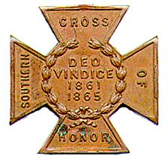
The SOUTHERN CROSS
Newsletter of the Sterling Price Camp #145
Sons of Confederate Veterans
St. Louis, MO
February 2016

Charge to the Sons
“To you Sons of Confederate Veterans, we will submit the vindication of the cause for which we fought. To your strength will be given the defense of the Confederate soldier’s good name, the guardianship of his history, the emulation of his virtues, the perpetuation of those principles he loved and which made him glorious and which you also cherish. Remember it is your duty to see that the true history of the South is presented to future generations.”
General Stephen Dill Lee

Camp Officers

Commander – Ray Cobb
First Lt. Commander – Bob Kennedy Second Lt Commander – Bill Napier
Sgt. at Arms – Dan Maltman Adjutant – Mike Harris

Camp Calendar and Other Events
John Harris has been doing an excellent job at lining up programs for the camp meetings. However he announced that because of new duties assumed as president of the St. Louis Civil War Roundtable, he is stepping down as program chair. We really appreciate his work on behalf of the camp. Here’s some of what he has in store for the new year. A year long look at the speakers we will have is found later

Tuesday, February 9, 2016 “The Flight of Jefferson Davis”
Gale Red, Dixon Camp SCV

Saturday, March 5, 2016 Confederate Flag Rally National Event
For more information, go to http://csaflag.org. MO plans are still in the works. For the Illinois event,
which may be more accessible for some of you, contact Michael Pierpoint at (618) 697-4472

Saturday, March 19, 2016 Swap Meet, Jefferson Barracks Recruitment Table
Bill Nappier will man the table but all are welcome.

Friday and Saturday, April 8 and 9, 2016 Missouri Division Reunion (see last two pages)
Isle of Capri Hotel/Casino, Boonville, MO
Commander-In-Chief Kelly Barrow will be speaking

Saturday, April 16, 2016 Military Civil War Ball
For more information go to www.StLouisCivilWarBall.com

July 13-17, 2015 121st National Reunion, Dallas, TX
For more information, go to www.scv2016.org

Please join us. All monthly meetings are held at Syberg’s Restaurant - Dorsett, 2430 Old Dorsett Rd, Maryland Heights, MO 63043. Directions: Syberg’s Dorsett is at the NE corner of the intersection of I-270 & Dorsett Rd, about one mile north of Page Ave. Fellowship begins at 5:30 and the meeting is called to order at 6:30. Are you interested in presenting at a program, or know of someone who is in 2016, contact John at a meeting or at thepooka342 @gmail. com.

Camp News
Mike Harris sent out an email today regarding a Civil War Ball, over a weekend in April. Go to the site listed in the Camp Calendar section. The site is blocked for me. There are also many other activities going on during the weekend, including a banquet and city tours, that your members may sign up for on our website, including another historical ball on Friday evening.

Darrell Maples has been contacted by the Army of the Trans-Mississippi regarding the position of ATM Executive Councilman. This position sits on the National SCV Executive Council. This is an opportunity to have Missouri represented on the SCV Executive Council and Darrell has formally declared his candidacy for the position. He’s done a tremendous job as Commander of the MOSB and I think I can say that we will give Darrell our full support

John Harris has been doing an excellent job at lining up programs for the camp meetings. However he announced that because of new duties assumed as president of the St. Louis Civil War Roundtable, he will be stepping down as program chairman. These will be big shoes to fill but please consider the opportunity to serve the camp in that capacity.

Anyone experiencing issues from the recent flooding? At last meeting, it was announced that Commander Maples received a call from Commander-in-Chief Kelly Barrow to let us know that for any SCV members that may be experiencing loss due to the recent flooding, that there is an SCV Relief Fund for assistance. The amount available, or what the criteria is to receive assistance, is unclear. But if any of your or your members have experienced loss due to the floods, we can sure find out. Please check with your respective memberships.

We can help the camp financially when we shop at Schnuck’s. If you identify yourself as an eScrip
participant or the camp, the Sterling Price Camp collects a percentage of what you spend each month.
Inquire at your local Schnuck’s store.

Minutes from the Sterling Price Camp Meeting
January 12, 2016

1. Meeting Called to Order – Commander Ray Cobb called the meeting to order at 6:30 PM, sharp!
2. Invocation – The Invocation was given by Camp Chaplain John Wilson.
3. Pledge of Allegiance – Led by 2nd Lt. Commander Bill Napier.
4. Salute to the Confederate Flag – Led by Compatriot Keith O’Connell.
5. Reading of Minutes & Treasurer’s Report – not given as Camp Adjutant Mike Harris is out of town
on vacation.

6. Communications by Camp Commander.
- Commander Cobb welcomed all guests including Maureen Harris, Dee Stratton, Ruth Killian,
and Sandie Burnett.
- The Commander reminded and encouraged attendance at the upcoming Missouri Division
Lee/Jackson Dinner, January 16th, at the Inn at Grand Glaze, Lake of the Ozarks, MO.
- The Commander also reminded and encouraged attendance at the upcoming annual Missouri
Division Reunion, April 8th & 9th, at the Isle of Capri Casino/Hotel in Boonville, MO where SCV
- CiC Barrow will be the featured speaker at the Awards Banquet.
- 2nd Lt. Commander Bill Napier reminded everyone that he will be manning his table at the
upcoming Jefferson Barracks Swap Meet, March 19th, both to sell his books and to serve as a “recruiting table” at the event. Anyone that would like to assist him in the recruiting endeavor
is welcome to participate.
- Compatriot John Harris reminded everyone that after the end of the current calendar year that
he will no longer be serving as the Camp Programs Chairman and is looking for someone to step
up and pick up this extremely important job for the Camp. In the interim he is willing to work
with the new volunteer to help him get his “feet wet” in preparing to take on this responsibility.
An interested/motivated volunteer is needed now!
7. Old Business – none.
8. New Business:
- Commander Cobb announced and there was general discussion about the Camp making a
donation toward the conservation of the 60th Virginia Inf. flag. The request for a contribution to this effort was made by a Compatriot of Black Horse SCV Camp #780 who is a descendant of a member of the 60th VA Infantry Regt. The Camp voted to make a $100 donation toward conservation of the 60th VA Infantry Regt. flag.
- There was also general discussion and consensus that the Camp should also consider making a
donation toward the defense of Confederate monuments in New Orleans, LA at a future date depending on further developments and request for assistance by the appropriate agency.
- Compatriot Gerasim (Gerry) Mayden also brought up and made a pitch for individual support of
the SLRC (Southern Legal Resource Center). Gerry stated that the SLRC has since 1995 provided legal resources and stood up and fought for Southern heritage and for the Southern people in the relentless PC attacks against everything pertaining to our Southern & Confederate heritage. The SLRC is a 501(c)3 nonprofit organization and all contributions including annual membership are
tax deductible. Their website is: www.slrc-csa.org.
9. Committee Reports: none given.
10. Program for the evening – “Missouri State Guard - Patriot Army of Missouri” – by Compatriot John Harris.
John gave a very interesting and informative presentation on the formation, history, and exploits of the Missouri State Guard during the period of the War Between the States. If anyone would like a PDF copy of the PowerPoint presentation that John used E-mail (halfleming@charter.net) and a copy will be sent to you.
11. Any other Announcements/Comments before Adjournment? – The next Camp meeting will be on Tuesday,
February 9th, same time, same place. The program for the evening will be: “The Flight of Jefferson Davis” by Compatriot Gale Red of the Dixon Camp, Belleville, IL.
12. Singing of “Dixie”- led by Compatriot/2nd Lt. Commander Bill Napier.
13. Benediction - Given by Camp Chaplain Pastor John Wilson, and meeting adjourned at approx. 7:50 PM.

Confederate Next Door

Charles Rice Black
October 10, 1841 – November 19, 1909
Private, Clardy’s Battalion

Charles Rice Black was born in St. Louis on October 10, 1841, on Walnut Street between Fourth and

Broadway, near the site of the old Spanish garrison. He was the 7th of 13 children born to Samuel and Amanda J. (McCutchan) Black. Sam was born in Virginia and was the nephew of Ralph Clayton, who moved in 1821 from Augusta County, VA to St. Louis County. Clayton was a pioneer in the development of this part of the area and later donated the 100 acres now used as the county seat. He had a tannery at which Sam worked until 1835 at which time he relocated to the city of St. Louis for 15 years in the livery business. Eventually, Sam purchased a farm a mile from Clayton in 1849.

Charles attended Webster Groves College at which his uncle Professor James Darrah was principal. He subsequently attended the St. Louis high school where he graduated in 1861. During the succeeding three years, he assisted his father in the livery business. In 1864, in response to a further call of the Confederacy for aid, Charles enlisted in Colonel Martin Clardy’s regiment which was then in Arkansas. The record for Clardy’s men has a William Black in it, presumably Charles. He served under the command of General Jeff Thompson who had just been exchanged for a Union general in the spring of 1864. He returned to Missouri shortly after to fight alongside Major General Sterling Price. Returning to southeast Missouri, he joined Major General Sterling Price's Missouri expedition, taking command of "Jo" Shelby's famed "Iron Brigade" when Shelby became division commander. Price's invasion of Missouri ended in defeat at the Battle of Westport in the fall of 1864.That campaign was defeated and Thompson surrendered his brigade in Arkansas on May 11, 1865. The soldiers were discharged 15 June 1865 at Wittsburg, Arkansas.[2]

After taking the oath of allegiance that was required of ex-Confederates, he returned in 1865 to his home
in Clayton. The next four years were spent as a bookkeeper in Holliman’s livery stable. He then joined his
father, who had removed to Dillon, MO outside Rolla, in Phelps County. There Mr. Black engaged in teaching school for two years. About 1872 he returned to St. Louis and taught in the Kennedy school at Price Road, 4 miles west of Clayton. He taught there for 17 years and was there after a director in the school for another 17 years.

In 1879, Mr. Black married Mary A. Woodward, daughter of Reverend William and Jane (Kennedy) Hawkins. Jane was the daughter of Dr. John Kennedy who came from Ireland and founded the school mentioned earlier. The Couple had two sons. Gurdon G. became engineer in charge of the purifying division of the St. Louis Water Department . James K. was an instructor of chemistry at Washington University. James would later give his life for his country in World War I. In 1887, Charles turned his attention to journalism, purchasing the Clayton Democrat from Walker Paine. Charles was editor and publisher until 1901. Under the name Clayton Argus, the paper became one of the most prominent representatives of the press in Missouri. At his death, he was serving as vice president for the St. Louis County Bank, of which he was an organizer and one time president,. Charles passed away at his home at 617 Central in Clayton suddenly, on November 19, 1909. His is buried in Bellefontaine Cemetery in Block 195, lot 5131.

Heritage Defense

The latest SCV Telegraph that Mike Harris sent out tells of the decision by the Lake City, FL voted to remove the Confederate flag from the city’s seal. (If you don’t receive the Telegraph, send Mike or me your email address.

Notable Quote

Any people, anywhere, being inclined and having the power, have the right to rise up and shake off the existing government, and form a new one that suits them better. This is a most valuable and most sacred right - a right which we hope and believe is to liberate the world. Nor is this right confined to cases in which the whole people of an existing government may choose to exercise it. Any portion of such people that can, may revolutionize, and make their own, of so many of the territory as they inhabit.Abraham Lincoln
Abraham Lincoln
January 12, 1848

Did You Notice?

In the latest issue of The Confederate Veteran, Missouri was noted as having donated a granite bench to the Enterprise Cemetery (p. 53) which includes a Confederate cemetery. Missouri men are buried there and the women’s Club flies the flags of all the states represented in the cemetery. Two hundred and nineteen of the 400 men have been identified. They are looking for flag donations, if you have any extras.

The Shapell Manuscript Foundation is currently updating the information on Jewish War of Northern Agression soldiers and sailors. They made a short film about the men. The trailer is at http://www.shapell.org/publications/films/. They are looking for information on at least the 3000 men mentioned in Simon Wolf’s roster from 1895 and are finding more Confederates.

This is an election year and there is a compatriot running for the NRA Board of Directors, Robert E. Thornton (Confederate Veteran, p. 61?). The NRA has refused to accept our advertising in the past. I may be an optimist but if we had the SCV members who are also members of the NRA flex their muscle, we may be able to change that. If you are a member of the NRA, you can use your bullet vote to cast all 25 ballots for the one candidate.

2016 PROGRAM
STERLING PRICE CAMP #145
SONS OF CONFEDERATE VETERANS

Tuesday, January 12, 2016 “Missouri State Guard, Patriot Army of Missouri”
John Harris, Sterling Price Camp SCV

Tuesday, February 9, 2016 “The Flight of Jefferson Davis”
Gale Red, Dixon Camp SCV

Tuesday, March 8, 2016 “Churchill's Corps at the Battle of Pleasant Hill”
Michael Banasik, Historian, Author and Retired US Army Officer

Tuesday, April 12, 2016 “The Rope and the Open Square:
Civil War Crime and Punishment”
Tom Pearson, Library Subject Specialist, Saint Louis Public Library

Tuesday, May 10, 2016 “Camp Jackson”
Gene Dressel, Utz Camp SCV

Tuesday, June 14, 2016 “The Sultana Tragedy”
William Napier, Sterling Price Camp SCV

Tuesday, September 13, 2016 “The Much Maligned Mountain Howitzer”
Charles Brulle, 1st Sergeant, 13th MO Light Artillery, CSA

Tuesday, October 11, 2016 “The Battle of Lexington”
Major (Retired) Douglas L Gifford, US Army, battlefield tour guide and author

Tuesday, November 8, 2016 “The Gettysburg Campaign”
Zachary Burnett, Sterling Price Camp SCV

Tuesday, December 13, 2016 “The Life and Times of Louis Rosché (1852-
1937); Pioneer Steamboatman of St. Louis”
Barney Bradshaw, Missouri History Museum

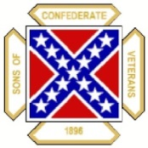
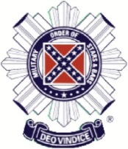
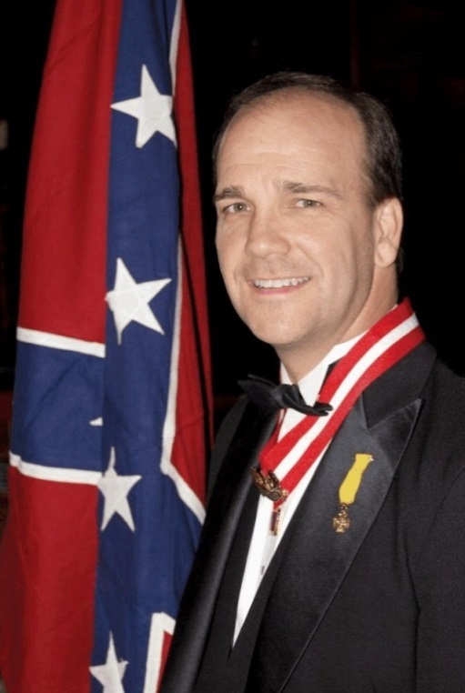
Missouri Division
Sons of Confederate Veterans Missouri Society
Military Order of the Stars & Bars

2016 Reunion
April 8-9, 2016
Isle of Capri Casino/Hotel Boonville, Missouri

Charles Kelly Barrow
Commander-in-Chief
Sons of Confederate Veterans
Featured Speaker
*** Hotel Reservations Must Be Made By March 24, 2016 ***

Registration Form
2016 Missouri Division Reunion Sons of Confederate Veterans April 8-9, 2016

Isle of Capri Casino/Hotel 100 Isle of Capri Blvd.
Boonville, Missouri

Name:

Guest:

Camp:

Phone No:

Email:

---------------------------------------------------------------------------------------------------------------------------------

Number attending MOS&B Luncheon: Number attending Awards Banquet:
x $18.00/person: $
x $29.00/person: $

Total Payment Enclosed: $ _____
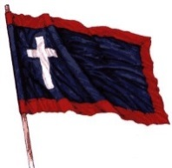
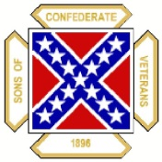

We have secured a rate of $109.99 + tax for Friday night and $179.99 + tax for Saturday Night with the Isle of Capri Hotel. Reservations can be made by calling the Hotel at: (800) 941-4753 or (660) 882-1200. Please mention “SCV Rate” when making reservations.
***** HOTEL RESERVATIONS MUST BE MADE BY MARCH 24, 2016 ***** The Isle of Capri is under new ownership and has changed the hotel room rate structure. We apologize for the increase in price, please consider other lodging shown below if this rate is unacceptable. Thank you for your understanding.

Other motels in Boonville:  Comfort Inn | Days Inn | Super 8 Motel
2427 MidAmerican Industrial Dr. | 2401 Pioneer Blvd. | 420 Americana
Boonville, MO | Boonville, MO | Boonville, MO
(660) 882-8137 | (660) 882-8624 | (660) 882-2900

Please make reservations as soon as possible and submit to:

Paul Lawrence - Adjutant
Missouri Division - SCV *** Make Checks Payable To: Missouri Division - SCV ***
280 North West 75th Road Centerview, MO 64019
If you have any questions, please do not hesitate to contact Commander Darrell Maples at:
(573) 635-8815. Email address is: pvtmape@embarqmail.com

