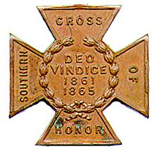
The SOUTHERN CROSS
Newsletter of the Sterling Price Camp #145
Sons of Confederate Veterans
St. Louis, MO
January 2016

Charge to the Sons
“To you Sons of Confederate Veterans, we will submit the vindication of the cause for which we fought. To your strength will be given the defense of the Confederate soldier’s good name, the guardianship of his history, the emulation of his virtues, the perpetuation of those principles he loved and which made him glorious and which you also cherish. Remember it is your duty to see that the true history of the South is presented to future generations.”
General Stephen Dill Lee

Camp Calendar and Other Events
John Harris has been doing an excellent job at lining up programs for the camp meetings. However he announced that because of new duties assumed as president of the St. Louis Civil War Roundtable, he is stepping down as program chair. We really appreciate his work on behalf of the camp. Here’s some of what he has in store for the new year. A year long look at the speakers we will have is found later

Tuesday, January 12, 2016 “Missouri State Guard, Patriot Army of Missouri”
John Harris, Sterling Price Camp SCV

Saturday, January 16, 2016 Lee Jackson Dinner, Inn at Grand Glaize

Tuesday, February 9, 2016 “The Flight of Jefferson Davis”
Gale Red, Dixon Camp SCV

Saturday, March 19, 2016 Swap Meet, Jefferson Barracks Recruitment Table

Friday and Saturday, April 8 and 9, 2016 Missouri Division Reunion (see last two pages)
Isle of Capri Hotel/Casino, Boonville, MO
Commander-In-Chief Kelly Barrow will be speaking

Please join us. All monthly meetings are held at Syberg’s Restaurant - Dorsett, 2430 Old Dorsett Rd, Maryland Heights, MO 63043. Directions: Syberg’s Dorsett is at the NE corner of the intersection of I-270 & Dorsett Rd, about one mile north of Page Ave. Fellowship begins at 5:30 and the meeting is called to order at 6:30. Are you interested in presenting at a program, or know of someone who is in 2016, contact John at a meeting or at thepooka342 @gmail. com.

Camp News
John Harris has been doing an excellent job at lining up programs for the camp meetings. However he announced that because of new duties assumed as president of the St. Louis Civil War Roundtable, he will be stepping down as program chairman. These will be big shoes to fill but please consider the opportunity to serve the camp in that capacity.

Anyone experiencing issues from the recent flooding? Commander Maples received a call
from Commander-in-Chief Kelly Barrow to let us know that for any SCV members that may be experiencing
loss due to the recent flooding, that there is an SCV Relief Fund for assistance. The amount available, or
what the criteria is to receive assistance, is unclear. But if any of your or your members have experienced
loss due to the floods, we can sure find out. Please check with your respective memberships.

CALL FOR ARTICLES and prayer requests. Please send items you think might be of interest to camp
members for inclusion in the Southern Cross. Or if you have a concern you want to share. Can’t think of
any, then organize a rally or grave marker dedication and send in photos. Send them to thanksarchie@hotmail.com or Southern Cross, P.O. Box 220084, Kirkwood, MO 63122

We can help the camp financially when we shop at Schnuck’s. If you identify yourself as an eScrip
participant or the camp, the Sterling Price Camp collects a percentage of what you spend each month.
Inquire at your local Schnuck’s store.

Minutes from the Sterling Price Camp Meeting

Sterling Price Camp Meeting Minutes
December 8, 2015

- Meeting Called to Order – Commander Kennedy called the meeting to order at 6:40 PM.
- Invocation – The Invocation was given by Commander Tom Kennedy.
- Pledge of Allegiance – The Pledge of Allegiance was led by Compatriot Jim England.
- Salute to the Confederate Flag – The Salute to the Confederate Flag was led Compatriot John Harris.
- Reading of the Minutes and Treasurer’s Report – A motion was made, seconded and passed to forgo the reading of the minutes of the November 10, 2015 camp meeting. The Treasurer’s Report was given by Adjutant Mike Harris. As of December 8, 2015, the balance in the primary checking account was $3686.82, primary savings was $1261.15 and the monument fund was $1922.52 for a total of $6870.49.
- Communications
- Commander Kennedy recognized our visitors, which included Eric Huddleston, Maureen Harris, Gene Dressel and Jake Lewis.
- Tom Kennedy has served as Camp Commander for the past four years and now much relinquish that role. Commander Kennedy thanks all of those in attendance at this camp meeting and especially those who attend camp meetings on a regular basis for making his four year term both a pleasure and a success.
- Commander Kennedy reported that he had received an e-mail from Joseph Scanio. Mr. Scanio had visited Metairie Cemetery in New Orleans and the grave of Lt. General Richard Taylor. Mr. Scanio discovered a Confederate Battle Flag at Gen. Taylor’s grave site which included, “Gen. Sterling Price Camp #145, St. Louis, MO” written on the flag. Mr. Scanio took the time to make pictures, look up our camp and send an e-mail with pictures to let us know how impressed he was at discovering the flag. Once again, our “Ambassador” Gary Mayden left one of his many mementos from his visit to Metairie Cemetery. Thank you Gary for representing our camp on your many travels.
- On Sunday, December 6, 2015 General Headquarters sent out a notification that for that day only,

Lifetime Memberships in the SCV would be sold at half price. Compatriot Gary Mayden and Mike
Snyder responded to this offer and are now Life Members of the SCV.
- The Lee-Jackson Dinner will take place on January 16, 2016 at the Grand Glaize Inn at Osage Beach, Missouri. The guest speaker will be James Pasley, Professor of History at Columbia College.
- The Jefferson Barracks Swap Meet will take place on March 19, 2016. Bill Napier will set up recruiting tables to solicit new members for the Price Camp.
- The Missouri Division Reunion will take place on April 8-9, 2016 in Boonville, MO at the Isle of Capri Casino. The guest speaker for the evening will be SCV Commander-in-Chief Charles Kelly Barrow.
- John Harris stated that the camp meeting speakers schedule for 2016 is complete. John has been our Program Director for a number of years and done an outstanding job. In 2016, he will become the President of the St. Louis Civil War Round Table and will vacate the Program Director role. Someone from the camp must agree to take on this responsibility.
- New officers were elected for a two year period beginning in January, 2016. Our camp
Our camp officers for the next two years are:
Commander – Ray Cobb
First Lt. Commander – Bob Kennedy
Second Lt Commander – Bill Napier
Sgt. at Arms – Dan Maltman
Adjutant – Mike Harris
- Old Business
There was no old business.
8. New Business
There was no new business.
9. Committee Reports
There were no committee reports.
10. Program for the Evening
John Harris introduced our guest speaker, Major (retired) Douglas L. Gifford, U. S. Army, who spoke to
us on “Where Valor and Devotion Met, The Battle of Pilot Knob.”
11. Any Other Announcements/Comments before Adjournment?
Our next camp meeting will be held on Tuesday, January 12, 2016.
12. Singing of Dixie
Compatriot Bill Napier led us in the singing of Dixie.
13. Benediction
Commander Ray Cobb led us in a closing prayer.

Confederate Next Door

Charles Branch
Shank's Company, Virginia Horse Artillery(?)
Virginia, C.S.A .

Charles Branch was born in Richmond, VA on January 8, 1842 to David Mann and Sarah Ellen Branch. The family moved to St. Louis in 1857 into the Fifth Ward of our city, with two sisters and four brothers. He graduated from St. Louis University High School, the first high school in St. Louis, and was a member of the first graduation class at Washington University. At the beginning of the war, he returned to Virginia and enlisted in the Confederate army. There were 3 Charles Branches in VA units, and only two used a middle initial. “Our” Charles Branch never used a middle initial before or after the war. So I believe he served in Shank’s Company , Virginia Horse Artillery, under Captain Daniel Shanks. I could find no specific information about the unit or Charles’ rank.

After the war, he returned to St. Louis. The Branch family lived at 1625 Morgan where his father

passed away Dec 18, 1869. In 1870, on October 27, Charles married Mary Glasgow. In 1880, he lived
with his in-laws. His father-in-laws occupation is listed as “capitalist.” Charles entered the insurance business, and up to the time of his death, was employed by the American Central Fire Insurance Company. Charles took great pride in the establishment of his private library and was widely known as a student of a large number of subjects. He was a charter member of the University Club, a member of the United Confederate Veterans, Sons of the American Revolution and Sons of the Colonial Wars. He lived for more than 50 years in St. Louis. He and Mary had at least 4 children, Annie, Sarah, Henry and David. When he died on January 6, 1915, the family resided in Webster Groves, at 200 Church Street. He was buried in Bellefontaine Cemetery, Block 16, Lot 2084. He rests beside his mother, father, wife Mary 2 brothers and one sister.

Heritage Defense

Commander Maples forwarded a copy of his letter to Michael Garvin in city hall regarding the Confederate Memorial monument that has stood in Forrest Park for 100 years. In it he makes a compelling argument for
the legitimacy of the monument and the cause that so many Missourians fought. He also highlights that the Mayor is single-handedly determining the fate of the Confederate monument without any input from the
Board of Aldermen. In it, Commander Maples also states that legal recourse and peaceful protests are a consideration. Mike Harris sent out a copy of the letter to members online

We had a request for assistance from SCV Camps organizations outside our area for financial assistance to preserve and protect our Confederate heritage. If you’re a Mizzou alum and usually send the university a generous check, please redirect your money to a more worthy and honorable cause. Confederate Heritage Matters!

The first was an email Ray Cobb received from William Caynor, Sr., a member of Black Horse SCV Camp #780.
“Many of you probably saw the email forwarded to Given both the season of giving as well as the intent and
goal of the SCV to “preserve the history and legacy of these heroes, so future generations can understand
the motives that animated the Southern Cause,” I seek your help and assistance to do just that.
I am requesting support and assistance to conserve and preserve the 60th Virginia Regimental battle flag. Please see the attached supporting letters and documentation referencing this Confederate battle flag.

I would also like to thank you, your officers, and your Camp Compatriots for doing what you do every day
to preserve the memory of our confederate ancestors. It is with immense honor that I dedicate my life in
the same fashion.”
William L. Caynor Sr., 60th Virginia Infantry Flag Sponsor
http://www.60thvirginiainfantryregiment.com

The second regarded events unfolding in New Orleans.

Subject: The situation in New Orleans : The City of New Orleans voted to remove the Confederate monuments from the city on a "nuisance complaint." This isn't over, so do not overreact to the situation. (The most imposing has had a commanding position over St. Charles Avenue since 1884: A 16-foot-tall bronze statue of Lee stands atop a 60-foot-high Doric marble column, which itself rises over granite slabs on an earthen mound. Four sets of stone staircases, aligned with the major compass points, ascend the mound.)

A lawsuit seeking to permanently enjoin and prevent the removal of the Confederate monuments was filed

in federal court only hours after the vote was taken in the city council. The federal judge has let everyone
know to cool it for now. There will be a hearing in January with the New Orleans City Attorney and the
attorney for the plaintiffs present and an injunction will be decided after that.
We all knew that this day was coming, so preparations were made and have now been implemented. The
time for phone calls and writing has passed…
What we will need is financial help. Like the doctor said when Lincoln was born, "This is gonna get ugly." It is also going to be expensive. ..Please send whatever you can because come January the fight will be on.
The address to send to is:
Beauregard Camp 130
P.O. Box 145
Arabi, LA. 70032
Please put in the memo line of your check "Monument Defense"

Charles Kelly Barrow
Commander-in-Chief
Sons of Confederate Veterans
@scvcic
www.scv.org
and Heritage Violations

Vandals topple graves, deface tombstones at historic Confederate cemetery
JANUARY 4, 2016
BY VICTOR SKINNER
http://www.theamericanmirror.com/vandals-topple-graves-deface-tombstones-at-historic-confederate-cemetery/

Vandals spray-painted “KKK” and “White Supremacist” on the headstones of several high-ranking Civil War officials in a Raleigh, North Carolina cemetery last week, the latest in a series of similar stunts.
“Cowardly acts like this, under the cover of darkness, late at night, aren’t perpetrated by decent and
thoughtful citizens,” Oakwood Cemetery Executive Director Robin Simonton said in a statement, according
to the News & Observer.

“In these modern times, conversations on divisive issues should be held in person. Midnight assassinations
don’t accomplish anything positive. Mature, non-emotional dialogue more often leads to agreement, or at
least compromise.”

Simonton’s view on the controversial folks resting in Oakwood Cemetery is a big reason why she hosts coffeehouse chats on morality and sunrise yoga on the grounds – to discuss important and divisive issues like race and slavery through civil discourse.

But the thugs who doused monuments with red paint, spray painted anti-racist messages on headstones,
and defaced other property causing an estimated $20,000 in damage apparently aren’t interested in civil discourse. They’re the same type of people who repeatedly defaced the “Silent Sam” monument on the University of North Carolina-Chapel Hill campus in 2014 and 2014, and who tagged a Confederate Women’s Memorial at the Capitol with “Black Lives Matter” this summer, according to the News & Observer.

A total of nine monuments inside a section of Oakwood dedicated to Confederate Army soldiers were
targeted in the attack, WNCN reports.

The culprits also hit a monument dedicated to former North Carolina Gov. Charles Aycock, who governed between 1901 and 1905. The damage included “KKK” spray-painted on the marker for Randolph Abbott Shotwell, a sharpshooter in the Civil War, and “Not Heroes” painted on a bronze and granite marker
dedicated to the crew of the Confederate submarine CSS H.L. Hunley, the News & Observer reports.
Gen. George B. Anderson’s grave was painted with “slavery” in large red letters, and red paint was splash
up the towering monument. Gov. Aycock’s grave, one not from the Confederate era, was labeled “White Supremacist” with black paint.

Simonton and local historian Bruce Miller, who leads tours through the cemetery, worked to cover the
graffiti with burlap and assess the damage over the weekend. Raleigh police confirmed to WNCN that
they’re investigating the incident, but would not discuss details. Cemetery officials also declined to allow
news crews
to film the graffiti.

“The people who did this don’t deserve to have any more credence given to what they’ve done. And out
of respect for the 25,000 folks that rest here, people come here for peaceful experiences and to celebrate
life and the words on these monuments don’t do any of that,” Simonton told ABC 11. She said officials
are working with a specialty company to determine how to clean up the paint without further damaging
the stone monuments.

“Some of these monuments are marble, and some of them are from 1870, so not only do we have to clean
it up but we have to protect the stone so that it will stay here forever,” Simonton said. The private, non-
profit cemetery is now soliciting donations to fix the damage, which is estimated to cost about $23,000, according to the news site.

And from the Wall Street Journal
Defenders of Confederate Symbols Mount a Counterattack
January 2, 3, 2016
Cameron McWhirter
http://www.wsj.com/articles/defenders-of-confederate-symbols-mount-a-counterattack- 1451695705?mod=trending_now_5

The article is available online. I found it interesting what’s going on at Stone Mountain;

In Georgia, a battle erupted at Stone Mountain, a granite outcropping east of Atlanta that bears 90-foot-tall likenesses of Confederate leaders chiseled in its side. The association that runs the state park proposed in October to place a “freedom bell” monument in honor of the Rev. Martin Luther King Jr. atop the mountain,
as a feel-good gesture.

But a local NAACP leader called the idea “a ploy” and said setting such a monument amid a park honoring
the Confederacy would be an insult to the Rev. King, unless all Confederate flags and place names were removed. State law explicitly requires rebel flags at the park. Leaders of the Georgia Sons of Confederate Veterans blasted the proposed additions as “disrespectful” changes to undermine the park’s purpose: to
honor their ancestors who fought.

In New Orleans

New Orleans Considers Removing Confederate Monuments
BY CAIN BURDEAU
ASSOCIATED PRESS
Dec 16 2015
http://hosted.ap.org/dynamic/stories/L/LA_CONFEDERATE_SYMBOLS?SITE=AP&SECTION=HOME&TEMPLATE=DEFAULT&CTIME=2015-12-16-15-40-46

NEW ORLEANS (AP) -- New Orleans is poised to make a sweeping break with its Confederate past as city leaders decide whether to remove prominent monuments from some of its busiest streets.

With support from Mayor Mitch Landrieu, a majority on the City Council appears ready to take down four monuments, including a towering statue of Confederate Gen. Robert E. Lee. Their ordinance has sparked passionate responses for and against these symbols, and both sides will get one more say at a special council meeting before Thursday's vote.

If approved, this would be one of the most sweeping gestures yet by an American city to sever ties with Confederate history.

Well, as reported the next day:

(CNN)A large crowd broke into cheers Thursday after the New Orleans City Council voted to remove four monuments to the Confederacy from prominent places in the city.

The 6-1 vote means officials will take down statues of Gens. Robert E. Lee, P.G.T. Beauregard and Jefferson Davis, President of the Confederacy. An obelisk dedicated to the Battle of Liberty Place will also go.
http://www.cnn.com/2015/12/17/us/new-orleans-confederate-monuments-vote/index.html

We’re not in this alone. It won’t be easy, or inexpensive, but it is worthwhile and can be a little bit of fun.
Remember:
“To you Sons of Confederate Veterans, we will submit the vindication of the cause for which we fought. To your strength will be given the defense of the Confederate soldier’s good name, the guardianship of his history, the emulation of his virtues, the perpetuation of those principles he loved and which made him glorious and which you also cherish. Remember it is your duty to see that the true history of the South is presented to future generations.”
General Stephen Dill Lee

2016 PROGRAM - TENTATIVE
STERLING PRICE CAMP #145
SONS OF CONFEDERATE VETERANS

Tuesday, January 12, 2016 “Missouri State Guard, Patriot Army of Missouri”
John Harris, Sterling Price Camp SCV

Tuesday, February 9, 2016 “The Flight of Jefferson Davis”
Gale Red, Dixon Camp SCV

Tuesday, March 8, 2016 “Churchill's Corps at the Battle of Pleasant Hill”
Michael Banasik, Historian, Author and Retired US Army Officer

Tuesday, April 12, 2016 “The Rope and the Open Square:
Civil War Crime and Punishment”
Tom Pearson, Library Subject Specialist, Saint Louis Public Library

Tuesday, May 10, 2016 “Camp Jackson”
Gene Dressel, Utz Camp SCV

Tuesday, June 14, 2016 “The Sultana Tragedy”
William Napier, Sterling Price Camp SCV

Tuesday, September 13, 2016 “The Much Maligned Mountain Howitzer”
Charles Brulle, 1st Sergeant, 13th MO Light Artillery, CSA

Tuesday, October 11, 2016 “The Battle of Lexington”
Major (Retired) Douglas L Gifford, US Army, battlefield tour guide and author

Tuesday, November 8, 2016 “The Gettysburg Campaign”
Zachary Burnett, Sterling Price Camp SCV

Tuesday, December 13, 2016 “The Life and Times of Louis Rosché (1852-
1937); Pioneer Steamboatman of St. Louis”
Barney Bradshaw, Missouri History Museum

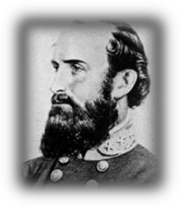
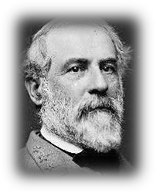
2016 Lee Jackson Dinner
January 16, 2016

Inn at Grand Glaize
Osage Beach, Missouri Social Time Begins At 5:30 p.m. Dinner Begins At 6:30 p.m.

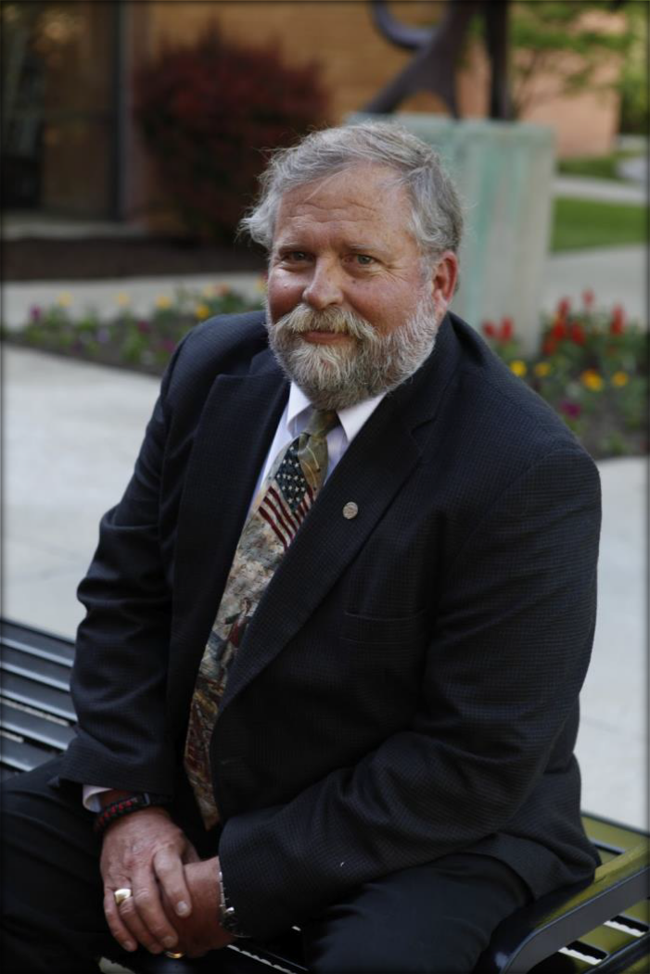
Guest Speaker

James Pasley
Professor of History
Columbia College

Subject Will Be:

The Confederate Flag Controversy And
The Battle of
“Monday Hollow”

You Won’t Want To Miss This One!

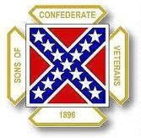
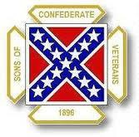
Missouri Division
Sons of Confederate Veterans
2016 Lee Jackson Dinner
Reservation Form

Name:

Guest(s):

Total Number Attending:_

Total Amount Enclosed:__________________________ ($30 per person)
Please send reservation and payment to: Paul Lawrence - Adjutant
Missouri Division SCV
280 North West 75^{t} Rd. Centerview, MO 64019

Make checks payable to: Missouri Division -SCV

Special Room Rate for those staying at the Inn at Grand Glaize Hotel/Resort:
$68.00 + tax

Inn at Grand Glaize
5141 Hwy. 54
P.O. Box 969
Osage Beach, MO 65065

Call the Inn at Grand Glaize direct at: 1-800-348-4731 and mention “SCV Rate”.

Registration Deadline is January 10, 2016, please get reservations in early! Any questions contact Darrell Maples at: (573) 635-8815
email: pvtmape@embarqmail.com

