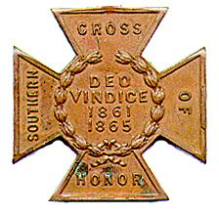
The SOUTHERN CROSS
Newsletter of the Sterling Price Camp #145
Sons of Confederate Veterans
St. Louis, MO
March 2016

Charge to the Sons
“To you Sons of Confederate Veterans, we will submit the vindication of the cause for which we fought. To your strength will be given the defense of the Confederate soldier’s good name, the guardianship of his history, the emulation of his virtues, the perpetuation of those principles he loved and which made him glorious and which you also cherish. Remember it is your duty to see that the true history of the South is presented to future generations.”
General Stephen Dill Lee

Camp Officers

Commander – Ray Cobb
First Lt. Commander – Bob Kennedy Second Lt Commander – Bill Napier
Sgt. at Arms – Dan Maltman Adjutant – Mike Harris

Camp Calendar and Other Events
John Harris has been doing an excellent job at lining up programs for the camp meetings. Here’s some of what he has in store for the new year. A year long look at the speakers we will have is found later.

Tuesday, March 8, 2016 “Churchill's Corps at the Battle of Pleasant Hill”
Michael Banasik, Historian, Author and Retired US Army Officer

Wednesday, March 9, 2016 Gale Red of the Belleville, IL, camp will be giving a talk at the
Church of the Shepherd in St. Charles, 11:00 am.
His talk will be on the capture of Jefferson Davis. See the details under Camp News.

Saturday, March 19, 2016 Swap Meet, Jefferson Barracks Recruitment Table
Bill Nappier will man the table but all are welcome.

Friday and Saturday, April 8 and 9, 2016 Missouri Division Reunion (see last two pages)
Isle of Capri Hotel/Casino, Boonville, MO
Commander-In-Chief Kelly Barrow will be speaking

Tuesday, April 12, 2016 “The Rope and the Open Square: Civil War Crime and Punishment”
Tom Pearson, Library Subject Specialist, Saint Louis Public Library

April 9, 2016 Lt. George E. Dixon Camp Annual Spring Ball to be held Saturday, in Belleville, Ill.
For details, look under Camp News.

Saturday, April 16, 2016 Military Civil War Ball
For more information go to www.StLouisCivilWarBall.com

July 13-17, 2015 121st National Reunion, Dallas, TX
Anyone wishing to attend the 2016 Re-union should go on-line (www.scv2016.org) and either fill out the registration online or make a copy of the registration and send it by mail. The registration form that appeared in the Confederate Veteran magazine should NOT be used as it now has outdated information.

Please join us. All monthly meetings are held at Syberg’s Restaurant - Dorsett, 2430 Old Dorsett Rd, Maryland Heights, MO 63043. Directions: Syberg’s Dorsett is at the NE corner of the intersection of I-270 & Dorsett Rd, about one mile north of Page Ave. Fellowship begins at 5:30 and the meeting is called to order at 6:30. Are you interested in presenting at a program, or know of someone who is in 2016, contact John at a meeting or at thepooka342 @gmail. com.

Camp News
Gale Red of the Belleville, IL, camp will be giving a talk next Wednesday, March 9th, at Church of the
Shepherd in St. Charles, 11:00 am. His talk will be on the capture of Jefferson Davis. Church of the
Shepherd, UMC, is Bob Arnold’s church. We're asked to bring along any Confederate items we'd like to display. Church of the Shepherd is located off Hwy 94 in St. Charles, between Jungermann and Woodstone,
and can be seen from 94 on the hill overlooking Walmart, South side of 94. To get to it, take either
Jungermann or Woodstone and circle around to the church which is on Woodstone, just off Old Hwy 94.
It's just across Woodstone from the post office.

Gale wanted to extend an invitation to all Price Camp members to attend the Lt. George E. Dixon Camp
Annual Spring Ball to be held Saturday, April 9, 2016 at the Bellecourt Manor, 225 East “A” Street, in
Belleville, Ill. Doors open 6:00 P.M. and the buffet starts at 6:30 P.M. Suggested attire is period clothing.
Cost is $35 per person, $256 for children under12 years. Deadline is March 19. Mike Harris emailed out
a flyer that goes into detail. If you have questions, Gale's phone number and e-mail address is listed on
the flyer. They are (618) 622-8949 and galered@yahoo.com.

Just a few updates about the April Missouri Division meeting.. There has apparently been some confusion
and communication problems on the Isle of Capri's part regarding the hotel rates. Lt. Commander Larry
Smith has got things cleared up now, and the rates are as they quoted them to us: $109.99 for the Friday
Night and $179.99 for Saturday Night. If you've made your reservations with the hotel, you may want to
call them back just to confirm these rates. Please try to get your dinner &/or luncheon reservations in early. As with all hotels, we have to provide a number to them about 10 days out. They do build in some wiggle room, but we need to give them as close to an accurate number as is possible. This becomes an
issue every year and it makes it VERY HARD for everyone involved, both on our end and on their end as well. PLEASE HELP US WITH THIS! Get your registrations sent to Adjutant Paul Lawrence at your earliest convenience.

The Military Civil War Ball is coming to St. Louis, on April 16, 2016. Tickets are $45, limited lodging rooms are available for $99 which includes breakfast and allows up to 4 guests per room. Light refreshments are
provided for the evening and an excellent band. Miss Deborah Hyland will be calling the dances for the evening. Tickets and information is posted on the website StLouisCivilWarBall.com. Or contact Joyce Melcher

at joycemelcher@hotmail.com. There are also many other activities going on during the weekend, including
a banquet and city tours, and historical ball on Friday evening.

News from across the State

Keeping with the spirit of an election year, at least two gentlemen have thrown their hats into the ring for the Missouri Division.

Compatriot Don Bowman -- Currently the Central Brigade Commander and the Camp Adjutant of the Col.
James J. Searcy Camp at Columbia has his announced his candidacy for the position of Missouri Division Adjutant.

Dave Roper is Commander of the Major James Morgan Utz Camp #1815 of Florissant, MO. He announced his candidacy for the position of Missouri Division - 1st Lieutenant Commander.

Get a big refund from Uncle Sam?? Even if you didn’t, you can help remember the Confederate veterans
of Missouri. The Confederate Memorial Friends Association gets their only revenue from donations. They
care for and host several events at the Higginsville site. It is only $10 for 1 year for the general membership,
or $25 a year for a contributing membership. If you did get a big refund, you may want to consider a
sustaining membership for $55 a year. Memberships can be sent to CMFA, Inc., Po Box 332, Higginsville, MO 64037-0332. Better yet, are you a Mizzou alum? Send your annual pledge to the CMFA.

Heritage Defense

Missouri House Bill 2476 has been filed by Representative Warren Love. Mike Harris sent acopy of the bill by email. Please note - this is by no means of a guarantee of ANYTHING. As with all bills, it must clear several hurdles. It must receive several "readings", then be assigned to a committee, get voted on and passed by the committee, before being brought to a vote of the House. It can also be amended during this process as well.
It would then have to pass the House before being moved to the Senate.

This bill is probably not perfect, but it is a start. Let us hope it does not die in committee and gets to the floor and beyond. Let us also thank Representative Love for his efforts and hard work.

Commander Maples asked that compatriots to contact their State Representatives at this time and let their
voices be heard. Again this is: House Bill 2476 establishes the Missouri Heritage Protection Act of 2016 to preserve any state historic military monument or memorial, marker, designated veterans' grave marker,
and statutorily designated monument or memorial. Darryl will continue to work very hard on this and keep
everybody posted as to any developments.

CONFEDERATE NEXT DOOR
John Sappington Parke, Jr.
Co. I, MO Infantry, CSA
December 1, 1843 – July 25, 1934

The Sappingtons were an old St. Louis family. John Sappington, a native of Maryland and a Revolutionary soldier, came to the area about 1806. His daughter Margaret married Jonah Parke who also had come to the area about 1804-6. These were the parents of John Sappington Parke. John Sappington Parke Jr. was the son of John Sappington Parke and Anna Mary Grether. In 1860 the family lived in the Bonhomme Township , a family that had grown to include 7 children. John Jr. served in the 10th Regt, enlisting is St. Louis County on

September 24, 1862 for 3 years “or the war.” The 10th Infantry Regiment [also called 12th Regiment] was organized in November, 1862. The unit was assigned to A.E. Steen’s, Parson’s and S.P. Burns brigade and was
action in Arkansas and Missouri. His particular unit, Company I , was under the leadership of Captain D. F. M. Sigler and Captain John McDaniel. John Jr. was captured at the Battle of Helena, Arkansas on July 4, 1863
and sent as a prisoner to Memphis on the steamer Tycoon. From Memphis he was transferred to Cairo July 5
on the steamer Silver Moon. He was transferred from Alton Military Prison to Fort Delaware on April 4 1864 where he arrived 4 days later. He was taken to City Point, VA for exchange Feb 27, 1865. John arrived in Richmond March 3, 1865 and was paroled at Camp Allen, June 8, 1865.

He married Lucretia Tyler, daughter of George Tyler and Nancy Smith Tyler. John and Lucretia had at least 4 children, Georgia, John Author, Robert M. and Stephen. In the 1880 city census his occupation was carpenter and resided at his brother’s house at 4595 Cote Brilliante. In the 1890 city directory he is listed as an architect residing at 2904 Gamble. In the 1930 Census he was a widower residing with his niece and nephew on Fillmore Avenue in Kirkwood. He entered into rest July 25 1934. He was buried at the Sappington Family Cemetery on Watson Road in Crestwood.
- 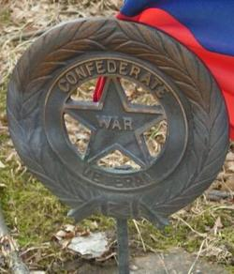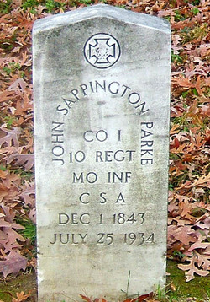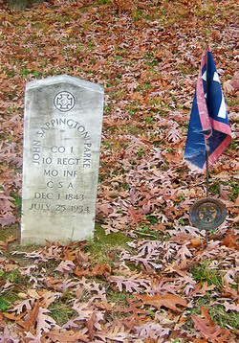
THE FOUR CHAPLAINS

On January 23, 1943, a transport ship named the U/S.S. Dorchester prepared to set sail from New York to an American base in Greenland carrying 904 service members. Many of them were little more than boys – young soldiers and sailors who have gone far from home, much like the soldiers 80 years earlier. Last to board the
ship were four chaplains. Four friends who knew not where there were heading to serve, but knew their purpose. To comfort and care for their fellow brothers in arms. These names were: Reverend George Fox,
Rabbi Alexander Goode, Father John Washington and Reverend Clark Poling. Chaplain Poling was quoted as saying to his father before boarding the Dorchester, “not for my safe return, that wouldn’t be fair. Just pray
that I shall do my duty…never be a coward…and have the strength, courage and understanding of men. Just
pray that I shall be adequate.” Little did Lt. poling or the other chaplains know at the time, but God would
soon answer that prayer in a mighty way.

The sailors had good reason to fear. Not just because the ship lurched violently in the water as it sailed the stormy seas. That was bad enough. The real danger was the German U-boats patrolling the North Atlantic. Hans Danielsen, captain of the Dorchester, had the men on high alert, ordering them to sleep in their cloths
and lifejackets due to a recent sonar sighting of a German submarine. Sadly most of the 904 men ignored the order. The first two torpedoes unleashed by the sub, U-223, missed their target. The third hit directly below
the waterline on the starboard side. A deafening explosion ripped open the ship, killing scores of men and injuring countless more while destroying the radio and knocking out the electricity. In a matter of minutes
the Dorchester and its crew would at the bottom of the Atlantic.

By the time the survivors reached the top deck, the ship was lurching deeper in to the wasters. With only the
moon providing light, panicked men rushed towards the lifeboats. Men jumping into the boats caused them
to capsize. Others dove into the freezing water to swim after rafts that had floated away, only to freeze to
death in minutes.

But just when things looked hopeless, there rose a calm in the midst of the ocean. A calm created by the four chaplains. When there were no more boats left, the four chaplains rushed to hand out life jackets. When the vests ran out, the four chaplains removed their vests and gave them to men. As survivors in the rafts watched the Dorchester sink beneath the waves, they witnessed an amazing sight. The four chaplains – men of different faiths but believing in the same God – arms linked on the sinking ship praying and singing hymens One witness later said, “they never made any attempt to save themselves, but the y did try to save the others. I think their names should go on the list of greatest heroes of this war.

In total, 672 U.S. soldiers perished at sea that night, including the four chaplains. But because of their bravery leadership and sacrifice, 230 men survived. News of the sinking ship moved the nation. On December 19, 1944 the four chaplains were posthumously awarded the Purple Heart and the Distinguished Service Cross. Since
their sacrifice was so heroic, Congress approved their own award, the Four Chaplains Medal, approved unanimously on July 14, 1960. Finally, in 1988, President Ronald Reagan and Congress created a new holiday commemorating the sacrifice of these men: Four Chaplains Day, February 3rd.

Source: No Greater Love. Pray In Jesus Name Ministries

Greater love hath no men than this, that a man lay down his life for his friends. John 15:13



2016 PROGRAM
STERLING PRICE CAMP #145
SONS OF CONFEDERATE VETERANS

Tuesday, January 12, 2016 “Missouri State Guard, Patriot Army of Missouri”
John Harris, Sterling Price Camp SCV

Tuesday, February 9, 2016 “The Flight of Jefferson Davis”
Gale Red, Dixon Camp SCV

Tuesday, March 8, 2016 “Churchill's Corps at the Battle of Pleasant Hill”
Michael Banasik, Historian, Author and Retired US Army Officer

Tuesday, April 12, 2016 “The Rope and the Open Square:
Civil War Crime and Punishment”
Tom Pearson, Library Subject Specialist, Saint Louis Public Library

Tuesday, May 10, 2016 “Camp Jackson”
Gene Dressel, Utz Camp SCV

Tuesday, June 14, 2016 “The Sultana Tragedy”
William Napier, Sterling Price Camp SCV

Tuesday, September 13, 2016 “The Much Maligned Mountain Howitzer”
Charles Brulle, 1st Sergeant, 13th MO Light Artillery, CSA

Tuesday, October 11, 2016 “The Battle of Lexington”
Major (Retired) Douglas L Gifford, US Army, battlefield tour guide and author

Tuesday, November 8, 2016 “The Gettysburg Campaign”
Zachary Burnett, Sterling Price Camp SCV

Tuesday, December 13, 2016 “The Life and Times of Louis Rosché (1852-
1937); Pioneer Steamboatman of St. Louis”
Barney Bradshaw, Missouri History Museum

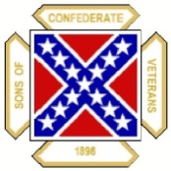
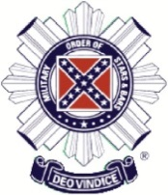
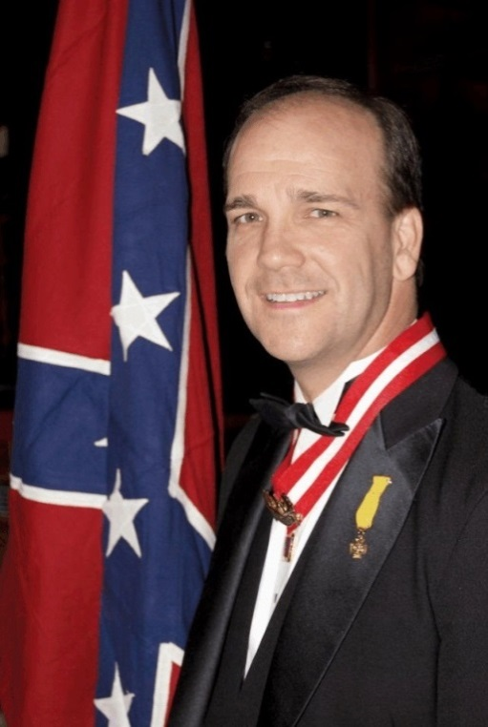
Missouri Division
Sons of Confederate Veterans Missouri Society
Military Order of the Stars & Bars

2016 Reunion
April 8-9, 2016
Isle of Capri Casino/Hotel Boonville, Missouri

Charles Kelly Barrow
Commander-in-Chief
Sons of Confederate Veterans
Featured Speaker
*** Hotel Reservations Must Be Made By March 24, 2016 ***

2016 Missouri Division Reunion
Sons of Confederate Veterans April 8-9, 2016

Tentative Schedule of Events

Friday Evening 6:00 p.m. - Commanders’ Reception - Social Time/Cash Bar/Gathering

Donnie and Ronnie Kennedy will be on site to deliver “An Evening With The Kennedy
Twins”! Meet Donnie and Ronnie, get their books, autographs and pictures!

This is a great time to spend with your Missouri Division Compatriots and a great time to
meet our Guest Speaker - Commander-in-Chief Kelly Barrow!

Saturday - April 9, 2016

8:30 a.m. Begin gathering for SCV Business Session 9:00 a.m. - 11:30 a.m. SCV Business Session

11:30 a.m. - 1:00 p.m. MOS&B Luncheon
Guest Speaker: Ronnie Kennedy

1:30 p.m. - 2:30 p.m. MOS&B Business Session

2:30 p.m. - 3:30 p.m. Special Presentation by Chris Edwards
Bringing Missouri’s Confederate Story to Branson!

6:00 p.m. - 7:00 p.m. Social Hour
* Cash Bar Available *

7:00 p.m. - ??? Awards Banquet
Guest Speaker - Charles Kelly Barrow - Commander-in-Chief Sons of Confederate Veterans

Registration Form
2016 Missouri Division Reunion Sons of Confederate Veterans April 8-9, 2016

Isle of Capri Casino/Hotel 100 Isle of Capri Blvd.
Boonville, Missouri

Name:

Guest:

Camp:

Phone No:

Email:

---------------------------------------------------------------------------------------------------------------------------------

Number attending MOS&B Luncheon: Number attending Awards Banquet:
x $18.00/person: $
x $29.00/person: $

Total Payment Enclosed: $ _____

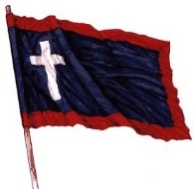
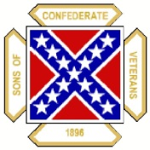

We have secured a rate of $109.99 + tax for Friday night and $179.99 + tax for Saturday Night with the Isle of Capri Hotel. Reservations can be made by calling the Hotel at: (800) 941-4753 or (660) 882-1200. Please mention “SCV Rate” when making reservations.
***** HOTEL RESERVATIONS MUST BE MADE BY MARCH 24, 2016 ***** The Isle of Capri is under new ownership and has changed the hotel room rate structure. We apologize for the increase in price, please consider other lodging shown below if this rate is unacceptable. Thank you for your understanding.

Other motels in Boonville:  Comfort Inn | Days Inn | Super 8 Motel
2427 MidAmerican Industrial Dr. | 2401 Pioneer Blvd. | 420 Americana
Boonville, MO | Boonville, MO | Boonville, MO
(660) 882-8137 | (660) 882-8624 | (660) 882-2900

Please make reservations as soon as possible and submit to:

Paul Lawrence - Adjutant
Missouri Division - SCV *** Make Checks Payable To: Missouri Division - SCV ***
280 North West 75th Road Centerview, MO 64019
If you have any questions, please do not hesitate to contact Commander Darrell Maples at:
(573) 635-8815. Email address is: pvtmape@embarqmail.com

