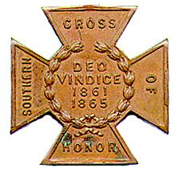
The SOUTHERN CROSS
Newsletter of the Sterling Price Camp #145
Sons of Confederate Veterans
St. Louis, MO
October 2016

Charge to the Sons
“To you Sons of Confederate Veterans, we will submit the vindication of the cause for which we fought. To your strength will be given the defense of the Confederate soldier’s good name, the guardianship of his history, the emulation of his virtues, the perpetuation of those principles he loved and which made him glorious and which you also cherish. Remember it is your duty to see that the true history of the South is presented to future generations.”
General Stephen Dill Lee

Camp Officers

Commander – Ray Cobb
First Lt. Commander – Bob Kennedy Second Lt Commander – Bill Napier
Sgt. at Arms – Dan Maltman Adjutant – Mike Harris

Camp CALENDAR

Tuesday, October 11, 2016 “The Battle of Lexington”
Major (Retired) Douglas L Gifford, US Army, battlefield tour guide and author

Saturday, October 22, 2016 Headstone Dedication for Private Martin Van Buren McQuigg
see details under Camp News 11:00 A.M
Sponsored by the Campbell’s Company Camp 2252 of Republic, MO

Saturday, October 29, 2016 Rededication of the 3 monuments – CSA, GAR and UDC Moberly, MO
2:00 P.M. see details under Camp News

Saturday, November 5, 2016 The Secession Day Dinner at the Inn at Grand Glaize
Lake of the Ozarks. MO.
Sign up sheet at the end of the newsletter

Tuesday, November 8, 2016 “The Gettysburg Campaign”
Zachary Burnett, Sterling Price Camp SCV

March 31 - April 1, 2017 Missouri Division/Missouri Society Reunion
Fulton, Missouri.

Please join us. All monthly meetings are held at Syberg’s Restaurant - Dorsett, 2430 Old Dorsett Rd, Maryland Heights, MO 63043. Directions: Syberg’s Dorsett is at the NE corner of the intersection of I-270 & Dorsett Rd, about one mile north of Page Ave. Fellowship begins at 5:30 and the meeting is called to order at 6:30. Are you interested in presenting at a program, or know of someone who is in 2016, contact Bill Napier, our Program Director.

Camp News
Membership dues are now due. They are $48 dollars payable to Adjutant Charles Knight, 17 Country Lane, Florissant, MO 63033-5524. Make the check payable to Sterling Price Camp 145

Missouri Division Confederate Flag Polo Shirts are available. The information is at the end of the newsletter. We need to do a camp order to save costs. Come to the next meeting.

Headstone Rededication Ceremony for Private Martin Van Buren McQuigg of Campbell’s Company – 7th Division Missouri State Guard will be October 22nd at 11 A.M. Private McQuigg lost his life on August 10, 1861 at Oak Hills. He is buried in Brick Church Cemetery of Farm Road 125 just northwest of the Springfield city limits. From I-44, take exit 75 US 169 (west bypass)/Willard and take a right (north). Make the first right (or east) on Farm Road 106. Follow the road until it makes a sharp turn to the right (southeast) at the T (Farm Road 106). Follow the road until it makes a sharp turn to the right (south- hurrah) and turns onto Farm Road 125. Right before the road makes a sharp turn to the left (east), you should see the cemetery on the right.

The three Civil War monuments in Moberly’s Oakland Cemetery have been restored. The rededication will be part of the city of Moberly’s 150 year celebration on Saturday, October 29th starting at 2:00 P.M. Posting of the Colors will start at the GAR’s Soldiers Monument on the west side of the cemetery. Procede to the GAR Lincoln Monument and end with the UDC Monument at the foot of the hill. There are well over 100 known soldiers of the at conflict buried in this cemetery. Take Rollins Street exit off Hiway 63 about 1 mile south of junction US. Hwy 24. Oakland Cemetery is on the north side of Rollins Street a very short distance from Hiwy 63.

The SCV will be breaking ground in October on THE NATIONAL CONFEDERATE MUSEUM at Elm Springs. There will be a plaque at the museum listing all the "founders" that give $1000 toward the museum fund. That’s’ a lot of money so would you consider sending $10, $25 or even $50? The information is in the latest Confederate Veterans magazine. It is also available through the web site.

SCV Relief Fund Letter - Please find attached a letter from Disaster Relief Committee Chair Danny Honnell of Arkansas. As you may all know, Louisiana got hit hard with flooding last week and several members are in need. He said more people have either asked for, or been recommended for, assistance than even followed Hurricane Katrina.
Compatriots and friends:
We, the descendants of Confederates, are in a new battle. I am asking you to stop for a few moments and read this letter asking you for a donation to the SCV Relief Fund.
As we all watched the news over the past few weeks showing the devastations in Louisiana and Texas, you could be looking at the faces of our compatriots that live in those areas. Most in the area have lost something, some have lost everything. Just think this could be you. Now you have a chance to help compatriots across this devastated region.

Last year we helped seven SCV members with relief and went over budget by $500. We have always been able to use what is budgeted. This year is different. I already have nine SCV members seeking relief and our resources are almost gone.

Our SCV Relief Fund is set up to be quick to get our members just a little money to get by until their insurance can kick in. We need for you to act now and spread the word so we can help as many members as we can.
As various disasters and catastrophic events occur and affect our membership, we must stand ready to assist our brothers and sisters in gray. We must prepare and distribute information on the level of relief we can provide based upon our available resources and the need to assist as many compatriots as possible in any given catastrophe. All levels of our organization must be made aware of the fund and its limitations. Assistance can only be provided as short term, stop gap measure and at the request of those needing the assistance.
If you give, your donation is tax deductible since we are a 501c 3 organization. Make checks payable to “Sons of Confederate Veterans” and in the memo section denote your donation for “SCV Relief Fund.” Mail checks to:
Sons of Confederate Veterans
c/o SCV Relief Fund
P.O. Box 59
Columbia, Tennessee 38402-0059
Do not wait. Reach in your pocket and give to the SCV Relief Fund today. For more information, please contact me directly at danny@honnoll.com or 870-926-2985. We sincerely thank you for your time and continued support.
Yours sincerely, / faithfully
W. Danny Honnoll
Now keep North Carolina in your prayers.
***************************************************************************************************************

CALL FOR ARTICLES and prayer requests. Please send items you think might be of interest to camp members for inclusion in the Southern Cross. Or if you have a concern you want to share. Can’t think of any, then organize a rally or grave marker dedication and send in photos. Send them to keithbashore@gmail.com or Southern Cross, P.O. Box 220084, Kirkwood, MO 63122.

Sterling Price Camp Meeting Minutes

September 13, 2016
1. Meeting Called to Order : The meeting was called to order by Commander Ray Cobb at 6:30PM.
2. Invocation: The invocation was given by Camp Chaplain John Wilson.
3. Pledge of Allegiance: The pledge of Allegiance was led by Compatriot Bill Napier.
4. Salute to the Confederate Flag : The salute to the Confederate Flag was led by Compatriot Michael
Harris.
5. Reading of the Last Meetings Minutes : A motion was made and seconded to forego the reading of the
Camp Minutes since they were in the Newsletter. The motion was amended to also forego the
Treasurer’s Report. It passed as amended.
6. Treasurer’s Report : See Above.
7. Announcements : Commander Ray Cobb gave information about future events. Consult the next
newsletter for the details.
8. Old Business : (None)
9. New Business :
a. A discussion, led by Commander Cobb, arose about the request by SCV HQ at Elm Springs for
each Camp to donate $1,000 to be used to complete our own SCV Confederate History
Museum. Rather than completely deplete the Camp’s funds the consensus was that each
member should make individual donations as they saw fit.
b. Compatriot Hal Fleming discussed the recent passing of MD Patrick Hardy’s Wife. Compatriot
Hardy has been a longtime generous member of our Camp and the SCV. In addition, he is a
past Sterling Price Camp Commander and Missouri Division Commander, as well as an officer
on the National HQ General Staff. Hal made a motion that the Camp donate $100 in memory of
Dr. Hardy’s late wife, Patricia A. Hardy, toward the SCV’s fundraising project to build the
National Confederate Museum at Elm Springs, Tenn. It passed.
c. The web-hosting (server) contract for the Camp’s website was set to expire on 31 August
2016. The Camp’s webmaster Andy Lewis was able to negotiate a new contract with a new
web-host “GoDaddy” for a much better deal, $143.64 for 3 years, vs. a 3 year price of $287.64
with the old web-host. Since the Camp Adjutant position was in a state of change at the time,
and time was of essence to get the change done by 31 August, Andy agreed to initially put the
renewal fee on his credit card if he were reimbursed right away. So, Compatriot Fleming agreed
to send Andy a personal check for $143.64 on behalf of the Camp until the Camp’s accounts got
transferred to the new Camp Adjutant’s name. Therefore a motion was made to reimburse
Compatriot Fleming for the $143.64 check that he sent to webmaster Lewis to cover the web-
hosting expense that he had initially paid for with his credit card. A motion was made to
reimburse him for the $143.64 he spent. That motion was amended to include 20 U.S. Postage
stamps to reimburse the Adjutant for his personal stamps used for Camp business and
authorize the purchase of replacement stamps and envelopes for the Camp’s office supplies.
The amended motion passed.
10. Program for the Evening
Program Chair, John Harris, introduced Friend of the Camp, Charlie Brulle, who spoke about “The
Much Maligned Mountain Howitzer”. The program was excellent. Charlie has an extensive knowledge
of the history of this weapon and its use. He has owned two of them, one of which he built himself and
he put his 25+ years of reenacting experience with this type gun and his enthusiasm for the history of it
in his report. If you are missing meetings you miss out on some fascinating history. Thank you Charlie.
11. Other Announcements Before Closing :(None)
12. The Singing of Dixie : Bill Napier led the camp in a heartfelt singing of “Dixie”.
13. Benediction : The meeting was closed with a prayer by Chaplain Charles Knight.

Prepared by the Adjutant

Heritage Defense/Attacks

There’s too many to touch on. This is one

Baltimore panel calls for removal of Confederate monuments
Wednesday, September 14, 2016 4:24 p.m. EDT
(Reuters) - A Baltimore commission has urged the removal of two city-owned Confederate monuments, including one to a Supreme Court justice notorious for a 19th century ruling against black Americans, the mayor said on Wednesday. There is one problem - no one wants the large bronze statues.

The special commission appointed by Mayor Stephanie Rawlings-Blake to study what to do with the city's four Confederate-themed monuments said that one to Supreme Court Chief Justice Roger Taney should be removed, the mayor said in a statement. Taney, a Maryland native, is best remembered for delivering the majority opinion in the 1857 Dred Scott case. The ruling found that African-Americans could not be considered U.S. citizens, whether they were free or slave. The decision created a furor among abolitionists and free states just before the 1861-65 American Civil War, which ended slavery in the United States. Maryland, straddling the North and South, was a slave state but remained in the Union during the war. The first fatalities of the conflict occurred in a Baltimore riot in April 1861.

In its report, the panel said that the double equestrian Lee and Jackson Monument to the two most venerated southern generals should be turned over to the National Park Service and placed at the Chancellorsville Battlefield in Virginia. The report recommended retaining monuments to Confederate service personnel and to Confederate women in the majority black city.

Symbols of the pro-slavery Confederacy became a flashpoint for already troubled U.S. race relations after a white gunman massacred nine African-Americans in Charleston, South Carolina, last year. The assailant was seen in photographs posing with the battle flag carried by Confederate soldiers.

So far, Baltimore has not found a party to take and relocate the monuments, a spokesman for Rawlings-Blake said. "We're going to be reaching out across the state to see if anyone would be interested in partnering with the city of Baltimore in obtaining these monuments," he said. In the meantime, the city plans to put up new signage at the four sites explaining their significance, the spokesman said.
Rioting broke out in Baltimore in April 2015 following the death of a black man, Freddie Gray, from a broken neck suffered in police custody. Six officers were charged but were either acquitted or had charges dismissed.

(Reporting by Ian Simpson in Washington; Editing by Alden Bentley)
http://wkzo.com/news/articles/2016/sep/14/baltimore-panel-calls-for-removal-of-confederate-monuments/

You’ll remember how quick the mayor of Baltimore and district attorney were to condemn the 6 police officers involved in the death of a black prisoner. Baltimore, as did Ferguson, burned because of political hacks and cowards. The black judge who tried the cases against the 6 found all of the officers not guilty of the charges the prosecutor brought. Guess we won’t be having the annual reunion in Baltimore anytime soon.

Editor’s Rambling

I’d like to write more but I’m up to me eyeballs in work. See you at Syberg’s.

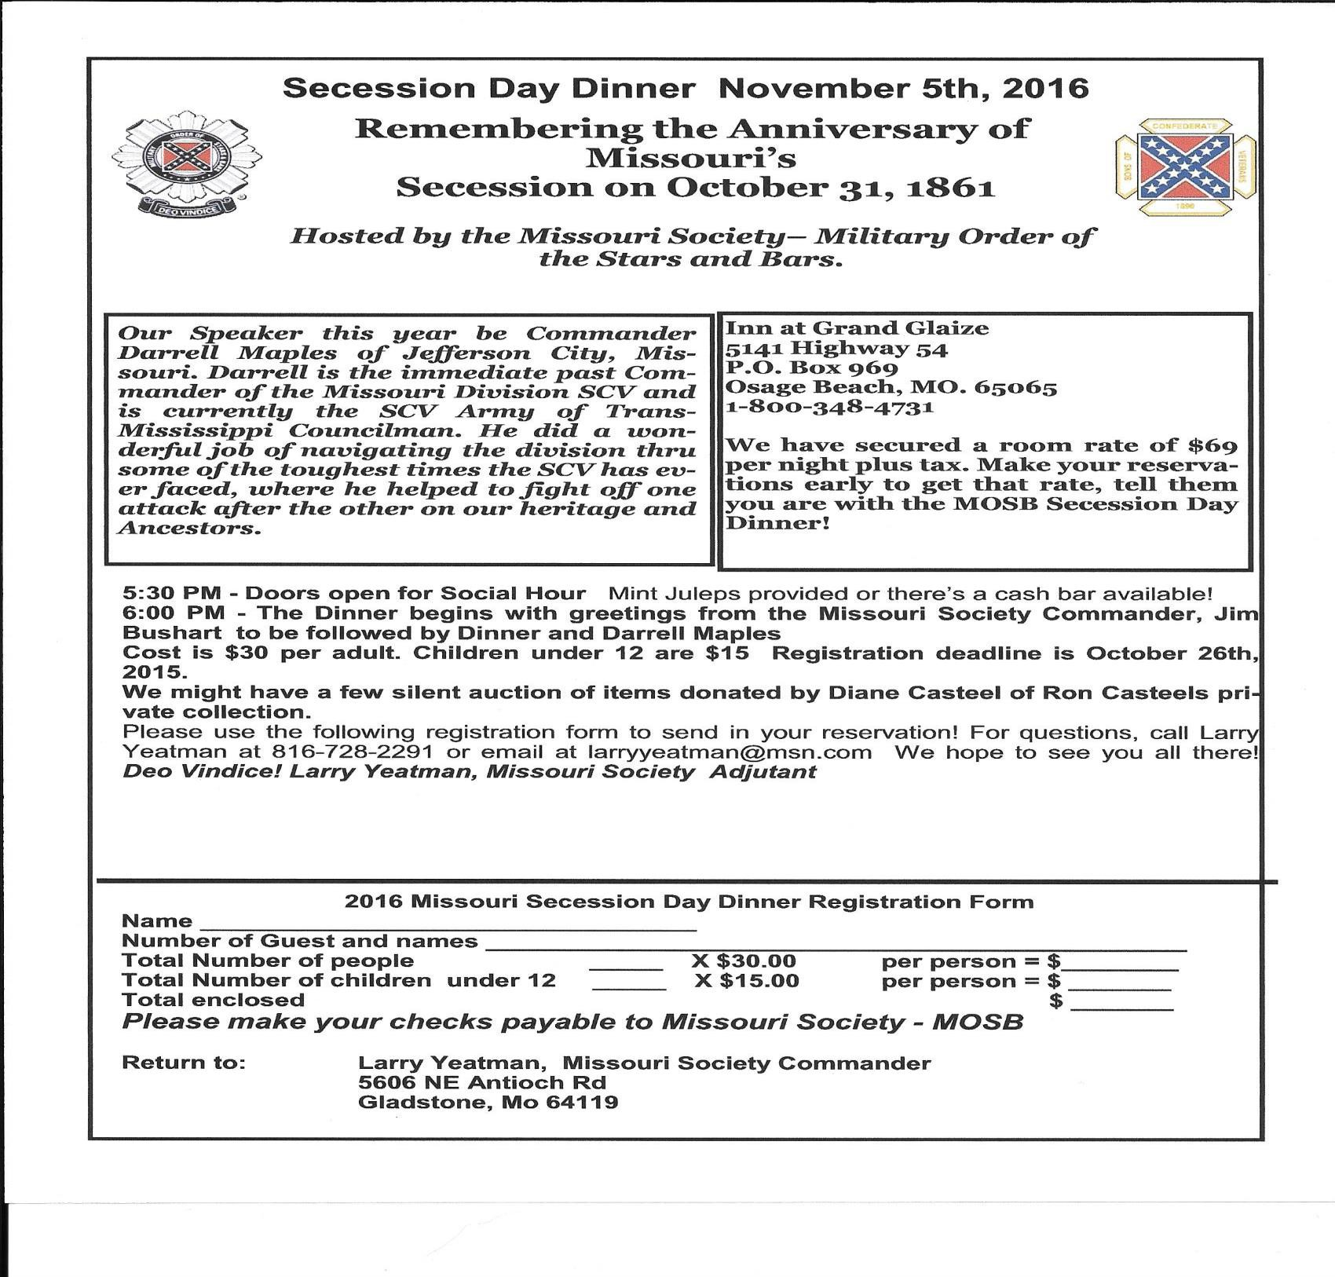

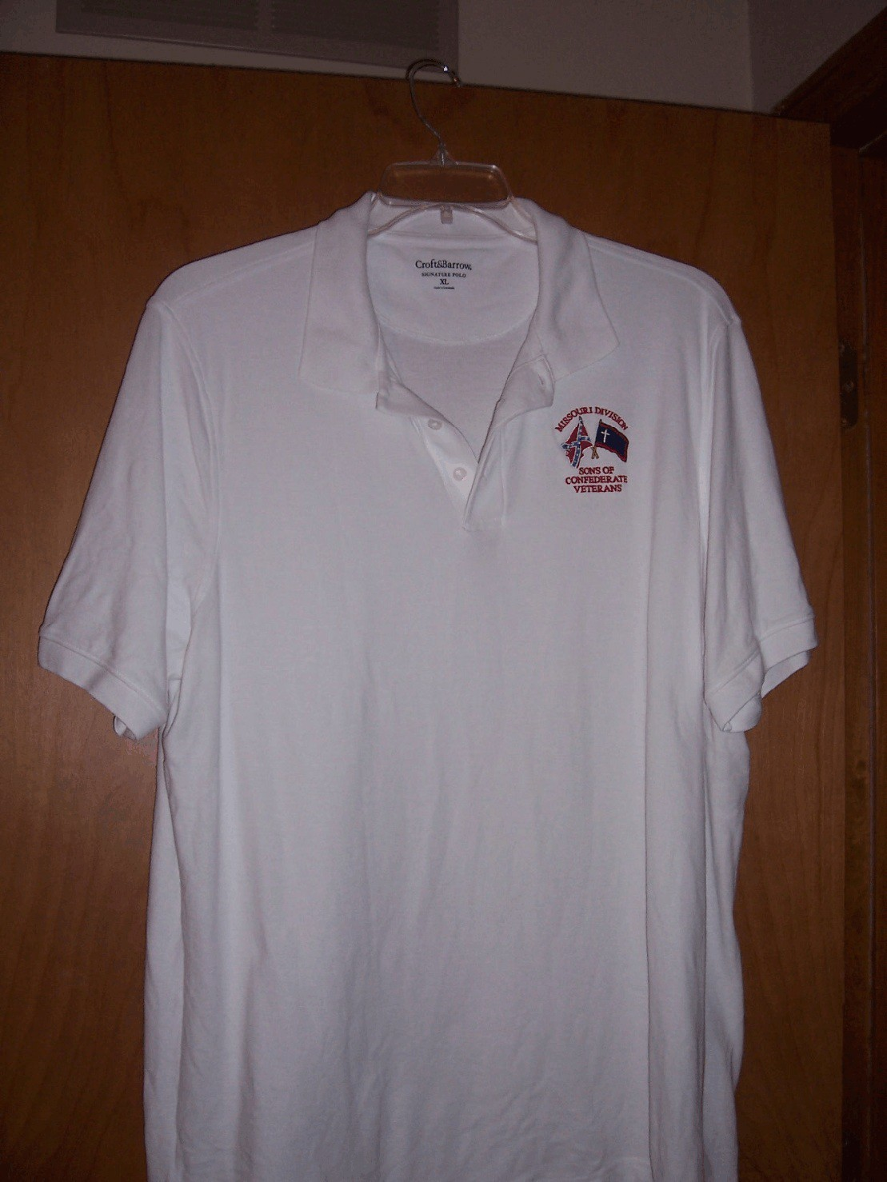

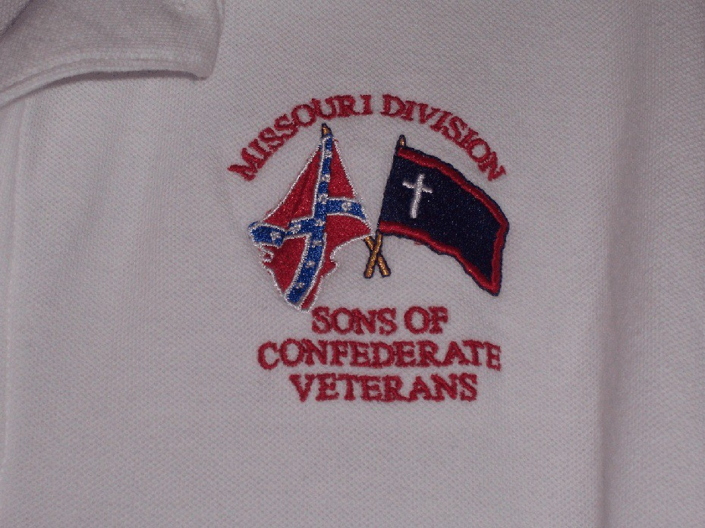

M

Missouri Division Confederate Flag Polo Shirt Order Form

Name or Camp Name/Number: ________________________________________________

Contact Person: ________________________________________________

Phone Number: ________________________________________________

Email: ________________________________________________

Shirts are available in White/Gray/Tan

Number of Shirts:__________ Size:__________ Color:__________ Total Cost:$_________

Number of Shirts:__________ Size:__________ Color:__________ Total Cost:$_________

Number of Shirts:__________ Size:__________ Color:__________ Total Cost:$_________

Number of Shirts:__________ Size:__________ Color:__________ Total Cost:$_________

Number of Shirts:__________ Size:__________ Color:__________ Total Cost:$_________

Number of Shirts:__________ Size:__________ Color:__________ Total Cost:$_________

All orders can be sent to:

Darrell Maples, 2416 Iven Rd., Jefferson City, MO 65101. Best to do
as a "Camp order" with all ordered at one time, and a mailing address to
send the shirts to. Checks made to MO Division - SCV.

* Use Back of Form if necessary

2016 PROGRAM
STERLING PRICE CAMP #145
SONS OF CONFEDERATE VETERANS

Tuesday, January 12, 2016 “Missouri State Guard, Patriot Army of Missouri”
John Harris, Sterling Price Camp SCV

Tuesday, February 9, 2016 “The Flight of Jefferson Davis”
Gale Red, Dixon Camp SCV

Tuesday, March 8, 2016 “Churchill's Corps at the Battle of Pleasant Hill”
Michael Banasik, Historian, Author and Retired US Army Officer

Tuesday, April 12, 2016 “The Rope and the Open Square:
Civil War Crime and Punishment”
Tom Pearson, Library Subject Specialist, Saint Louis Public Library

Tuesday, May 10, 2016 “Camp Jackson”
Gene Dressel, Utz Camp SCV

Tuesday, June 14, 2016 “The Sultana Tragedy”
William Napier, Sterling Price Camp SCV

Tuesday, September 13, 2016 “The Much Maligned Mountain Howitzer”
Charles Brulle, 1st Sergeant, 13th MO Light Artillery, CSA

Tuesday, October 11, 2016 “The Battle of Lexington”
Major (Retired) Douglas L Gifford, US Army, battlefield tour guide and author

Tuesday, November 8, 2016 “The Gettysburg Campaign”
Zachary Burnett, Sterling Price Camp SCV

Tuesday, December 13, 2016 “The Life and Times of Louis Rosché (1852-
1937); Pioneer Steamboatman of St. Louis”
Barney Bradshaw, Missouri History Museum

