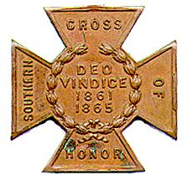
The SOUTHERN CROSS
Newsletter of the Sterling Price Camp #145
Sons of Confederate Veterans
St. Louis, MO
September 2016

Charge to the Sons
“To you Sons of Confederate Veterans, we will submit the vindication of the cause for which we fought. To your strength will be given the defense of the Confederate soldier’s good name, the guardianship of his history, the emulation of his virtues, the perpetuation of those principles he loved and which made him glorious and which you also cherish. Remember it is your duty to see that the true history of the South is presented to future generations.”
General Stephen Dill Lee

Camp Officers

Commander – Ray Cobb
First Lt. Commander – Bob Kennedy Second Lt Commander – Bill Napier
Sgt. at Arms – Dan Maltman Adjutant – Mike Harris

Camp CALENDAR

Tuesday, September 13, 2016 “The Much Maligned Mountain Howitzer”
Charles Brulle, 1st Sergeant, 13th MO Light Artillery, CSA

Saturday September 24, 2016 Ste. Genevieve
See information under Camp News

Saturday, October 1, 2016 Missouri State Guard Flag Dedication
See information under Camp News

Tuesday, October 11, 2016 “The Battle of Lexington”
Major (Retired) Douglas L Gifford, US Army, battlefield tour guide and author

November 5, 2016 The Secession Day Dinner at the Inn at Grand Glaize
Lake of the Ozarks. MO.
Sign up sheet at the end of the newsletter

March 31 - April 1, 2017 Missouri Division/Missouri Society Reunion
Fulton, Missouri.

Please join us. All monthly meetings are held at Syberg’s Restaurant - Dorsett, 2430 Old Dorsett Rd, Maryland Heights, MO 63043. Directions: Syberg’s Dorsett is at the NE corner of the intersection of I-270 & Dorsett Rd, about one mile north of Page Ave. Fellowship begins at 5:30 and the meeting is called to order at 6:30. Are you interested in presenting at a program, or know of someone who is in 2016, contact Bill Napier, our Program Director.

Camp News
Our condolences go out to former Commander Pat Hardy on the loss of his wife of 57 years Patricia. Internment was at the National Cemetery Jefferson Barracks. In lieu of flowers, the family requested donations to the charity of your choice.

Membership dues are now due. They are $48 dollars payable to Adjutant Charles Knight, 17 Country Lane, Florissant, MO 63033-5524. Make the check payable to Sterling Price Camp 145

Missouri Division Confederate Flag Polo Shirts are available. The information is at the end of the newsletter. We need to do a camp order to save costs. Come to the next meeting.

State Guard Flag Dedication - The Missouri Division has been given a tremendous opportunity to have the State Guard flag put on permanent display at the Missouri Military Museum located at the MO National Guard Headquarters just east of Jefferson City. The Parsons Camp has obtained a 3’ x 5’ flag and during our July camp meeting we conducted a blessing of the flag prayer service for the flag. On October 1st at 1:00 p.m. we are going to present the flag to the museum director as a part of the 2nd Annual Missouri Military History Weekend program. The street address is 2302 Militia Drive, Jefferson City, MO. From Jefferson City go East on Highway 50 to the Militia Drive turnoff. At top of ramp turn left and this will take you straight into the Ike Skelton Training/National Guard HQ Complex/ The Missouri Military Museum is immediately on your right after you go through the main gate check point. Show the security guard you driver’s license and tell him/her that you are going to the museum. Just watch for the C-130, the Cobra Gunship, the F-15 and turn into the parking lot. You will see tents and living history displays all on your right. - Randee Kaiser, Adjutant, M. M. Parsons Camp #718
The SCV will be breaking ground in October on THE NATIONAL CONFEDERATE MUSEUM at Elm Springs. There will be a plaque at the museum listing all the "founders" that give $1000 toward the museum fund. That’s’ a lot of money so would you consider sending $10, $25 or even $50? The information is in the latest Confederate Veterans magazine. It is also available through the web site.

SCV Relief Fund Letter - Please find attached a letter from Disaster Relief Committee Chair Danny Honnell of Arkansas. As you may all know, Louisiana got hit hard with flooding last week and several members are in need. He said more people have either asked for, or been recommended for, assistance than even followed Hurricane Katrina.
Compatriots and friends:
We, the descendants of Confederates, are in a new battle. I am asking you to stop for a few moments and read this letter asking you for a donation to the SCV Relief Fund.
As we all watched the news over the past few weeks showing the devastations in Louisiana and Texas, you could be looking at the faces of our compatriots that live in those areas. Most in the area have lost something, some have lost everything. Just think this could be you. Now you have a chance to help compatriots across this devastated region.

Last year we helped seven SCV members with relief and went over budget by $500. We have always been able to use what is budgeted. This year is different. I already have nine SCV members seeking relief and our resources are almost gone.

Our SCV Relief Fund is set up to be quick to get our members just a little money to get by until their insurance can kick in. We need for you to act now and spread the word so we can help as many members as we can.
As various disasters and catastrophic events occur and affect our membership, we must stand ready to assist our brothers and sisters in gray. We must prepare and distribute information on the level of relief we can provide based upon our available resources and the need to assist as many compatriots as possible in any given catastrophe. All levels of our organization must be made aware of the fund and its limitations. Assistance can only be provided as short term, stop gap measure and at the request of those needing the assistance.
If you give, your donation is tax deductible since we are a 501c 3 organization. Make checks payable to “Sons of Confederate Veterans” and in the memo section denote your donation for “SCV Relief Fund.” Mail checks to:
Sons of Confederate Veterans
c/o SCV Relief Fund
P.O. Box 59
Columbia, Tennessee 38402-0059
Do not wait. Reach in your pocket and give to the SCV Relief Fund today. For more information, please contact me directly at danny@honnoll.com or 870-926-2985. We sincerely thank you for your time and continued support.
Yours sincerely, / faithfully
W. Danny Honnoll
***************************************************************************************************************
On Saturday, 24 September, 2016 The Jeff Thompson Camp will be assisting the SUV with an event (as CONFEDERATES of course.) I, and the M. Jeff Thompson Camp, would like to invite you and your members as well. For those participating in the "reenactment," period civilian and early war impression is needed. The SUV Camp would like us to be the rabble rousers in the crowd and the ones to chase them out of Ste. Genevieve. I believe we can definitely be the REBELS we are. The Thompson Camp will also have a recruiting tent set up. This should be a lot of fun and the joint effort could pay great political dividends.
Ste. Genevieve Militia Site (Corner Gabour Street & Front Street)
10 a.m. to 3 p.m.
Bank Raid 1 p.m.
The bank raid will take place near the site of the original bank site on the corner of Merchant and Main. What we would like those of your group to participate in the bank raid and if we have a crowd we could use maybe a couple of agitators in the crowd.
The bank raid will consist of Union taking the money out of the bank. We are looking for someone to play Firmin Rozier who was the bank president and pro-Southern. We are stretched thin on Union member. Union troops will approach from the South on Main Street from the camp area which is about 4 blocks. They will stop at the corner of Merchant and Main where they will spend about 10 minutes going through that scenario with a reading of the Major John MacDonald.
Confederate troops will march down Main Street from the corner of Jefferson and Main Street starting out at the City bathroom site on that corner. The Union troops will perform a fighting withdrawal back to the railroad bridge on the corner of Main and Gabouri Street.

CALL FOR ARTICLES and prayer requests. Please send items you think might be of interest to camp members for inclusion in the Southern Cross. Or if you have a concern you want to share. Can’t think of any, then organize a rally or grave marker dedication and send in photos. Send them to keithbashore@gmail.com or Southern Cross, P.O. Box 220084, Kirkwood, MO 63122.

Sterling Price Camp Meeting Minutes
June 8, 2016
- Meeting Called to Order – The meeting was called to order at 6:30 PM sharp by Past Commander Hal Fleming
at the request of Commander Ray Cobb due to a personal issue of not being able to make it to the meeting by
start time.
- Invocation – The invocation was given by Camp Chaplain John Wilson.
- Pledge of Allegiance – The pledge was led by Compatriot and Program Chair John Harris.
- Salute to the Confederate Flag – The salute was led by Past Camp and Missouri Division Commander Jim England.
- Reading of the Minutes & Treasurer’s Report – There was a motion by Compatriot & 2nd Lt. Commander Bill Napier to forego the reading of the minutes. The motion was seconded and a voice vote passed (all “Aye”) to forego the reading of the minutes. The minutes for the May 10th, 2016 meeting can be found in the June 2016 edition of the Camp newsletter, “The Southern Cross.” The Treasurer’s Report was not given as Camp Adjutant Mike Harris was unable to attend the meeting.
- Old Business – Past Commander Fleming mentioned that at a recent previous Camp meeting that someone had brought up the subject of the Camp providing some financial support to the Beauregard Camp #130 of New Orleans, Louisiana in their fight against the City of New Orleans and the Mayor’s plan to remove all Confederate Monuments and references to anything Confederate in that city. He also referenced a plea for assistance by the Commander of the Louisiana Division (SCV) in a letter to the editor in the “Dispatches from The Front” section in the most recent edition of the “Confederate Veteran” magazine. There is also a full page ad by the Beauregard Camp (#130) in the same edition of the “CV” asking for financial assistance in their legal battle against the City’s plan to remove all references to the Confederacy in the City of N.O. Compatriot & 2nd Lt. Commander Bill Napier made a motion that the Sterling Price Camp make a donation of $500 to the Beauregard Camp for use in their legal battle with the City of N.O. against removal of all things Confederate in the City. The motion was seconded and a voice vote passed (all “Aye”) to make a donation of that amount.
- New Business – Current Camp Commander Ray Cobb arrived at about 7:00 PM and after bringing him “up to speed” on the status of the meeting the “reigns” were turned over to him. Commander Cobb then brought up the Missouri Division’s plan to put up signage across the state in support of and for recruiting purposes for the Sons of Confederate Veterans.
New member “Swearing In” – Past Cadet member Sam Kennedy was “sworn in” as a Regular Member by Commander Cobb and by “Acting Adjutant” 1st Lt. Commander Bob Kennedy, Sam’s grandfather! Welcome aboard as a Regular Member Compatriot Sam Kennedy!
- Committee Reports – None.
- Program for the evening – Compatriot & 2nd Lt. Bill Napier gave the presentation for the evening program. His topic was “The Sinking of the Sultana” which occurred on April 27, 1865. It was the greatest maritime tragedy in U.S. history. The ship was extremely over loaded with recently released Union prisoners of war. There were a few survivors but an estimated 1800 individuals lost their life in the tragedy. In spite of the enormity of the disaster, no one was ever held accountable. Compatriot gave a very interesting and enthusiastic presentation.
- Other announcements or comments before adjournment – As normal there will be no Camp meeting in July or August. The next meeting will be this coming September 13th.
- Singing of Dixie – Let by Past Commander Jim England.
- Benediction – given by Camp Chaplain John Wilson.

Note: Minutes of the meeting were taken by Past Camp Commander Hal Fleming in lieu of Adjutant Mike Harris being unable to attend.

Heritage Defense/Attacks

Yale Cafeteria Worker Resigns After Breaking “Racist,” One-of-a-Kind Stained Glass

By Emily Zanotti|11:22 pm, July 11, 2016
A Yale cafeteria worker has resigned after smashing a historic stained glass window in Yale’s notorious Calhoun College residence hall, which is named after the 19th century white supremacist John C. Calhoun. The stained glass depicted two slaves picking cotton.
The worker, Corey Menafee, is black. He told the New Haven Independent that the dining hall window was “racist” and “very degrading” and that last month, while working an event for the college, he decided to use a broomstick to smash the window.

“I took a broomstick, and it was kind of high, and I climbed up and reached up and broke it,” he told the Independent. “It’s 2016, I shouldn’t have to come to work and see things like that.
“I just said, ‘That thing’s coming down today. I’m tired of it,’” he added. “I put myself in a position to do it, and did it.” City police arrested Menafee, who now faces a felony charge.

The stained glass window is one of many at Yale deemed offensive by modern standards. For many years, it was concealed by plexiglass and didn’t become widely visible until after a recent renovation. Another stained glass depiction of John C Calhoun with a slave kneeling before him was altered in the early 1990s (to remove the slave). Yet another offensive stained glass image, of a black person eating watermelon, was removed from Yale’s main library in the mid-1990s.
As for Calhoun College itself, the long-running controversy over its name finally came to the fore just this year when Yale officials, after much hand-wringing, announced that they would not strip the former vice president’s name from the college. The move appeared to be a concession to Yale’s powerful alumni.

Menafee,the worker who broke the window, says he regrets what he did because it cost him his job, but says he believes his actions were justified. “It could be termed as civil disobedience,” Menafee told the New Haven Independent. “But there’s always better ways of doing things like that than just destroying things. It wasn’t my property, and I had no right to do it.”
Yale says the breaking of the glass presented a safety issue — that some glass fell onto a sidewalk and hit a passing woman, who was not injured. Yale also says it will not advocate for the criminal charges to be pursued against Menafee.

http://heatst.com/culture-wars/yale-cafeteria-worker-resigns-after-breaking-racist-one-of-a-kind-
stained-glass/

Vanderbilt pays $1.2M to remove ‘Confederate’ from dorm name

By Associated Press
August 16, 2016

NASHVILLE, Tenn. — Vanderbilt University announced Monday that it will pay more than a million dollars to remove an inscription containing the word “Confederate” from one of its campus dorms. The private university has referred to Confederate Memorial Hall simply as “Memorial Hall” since 2002, but was blocked in court from changing the name chiseled on the building because it was constructed with the help of a $50,000 gift from the United Daughters of the Confederacy in 1933.

Under the agreement, Vanderbilt will pay $1.2 million, the equivalent of the gift made 83 years ago, to the organization’s Tennessee chapter. In exchange, the chapter will relinquish its naming rights to the building. “You can memorialize individuals without taking sides in the bloodiest war that was fought over the divisive issues of slavery and equality that we’re still struggling with today for those young people coming onto campus,” Vanderbilt Chancellor Nicholas Zeppos said in a phone interview.

About 30 miles to the southeast, Middle Tennessee State University in Murfreesboro wants to remove the name of Confederate Gen. Nathan Bedford Forrest from one of its buildings. The public higher education system overseeing the school endorsed the change last month, but the proposal faces a tougher hurdle when it reaches the Tennessee Historical Commission.

Under the “Tennessee Heritage Protection Act” passed earlier this year, it now takes a vote of at least two-thirds of the commission to approve changing or removing historical markers. That’s an increase from the previous requirement of a simple majority vote.

After the defeat of the Confederacy, the newly formed Ku Klux Klan elected Forrest its honorary grand wizard, though he publicly denied being involved. Two years later, he ordered the Klan to disband because of its members’ increasing violence. The Forrest bust remains in the lobby between the House and Senate chambers at the state Capitol.

http://nypost.com/2016/08/16/vanderbilt-pays-1-2m-to-remove-confederate-from-dorm-name/

Editor’s Rambling

This is Israel’s memorial to 9/11.
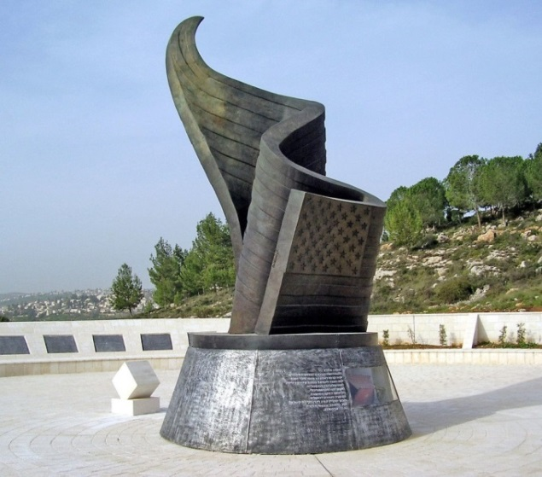
It is called the 9/11 Living Memorial Plaza.
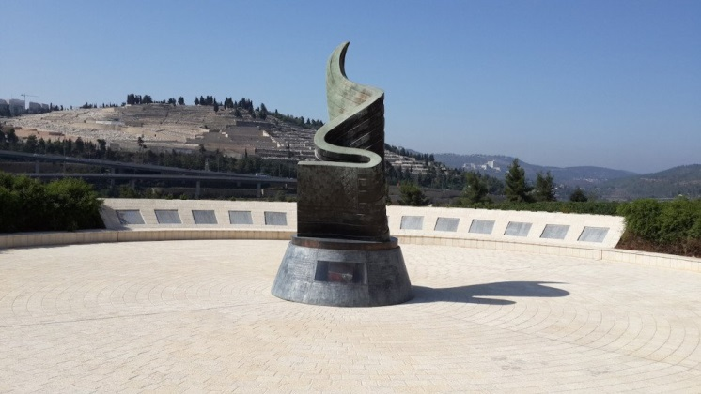
Completed in 2009 for $2 million, it sits on 5 acres of hillside, 20 miles from the center of Jerusalem. The memorial is a 30-foot, bronze American flag.
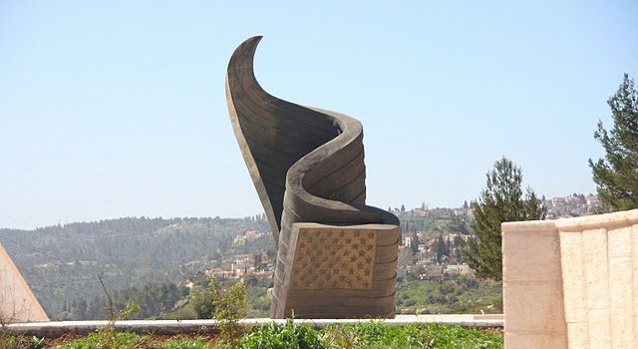
That forms the shape of a flame to commemorate the flames of the Twin Towers. The base of the monument is made of melted steel from the wreckage of the World Trade Center. And includes this engraving in Hebrew and English.
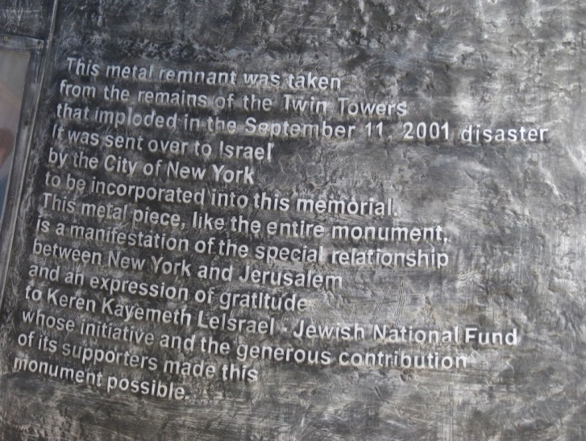
“This metal remnant was taken from the remains of the Twin Towers, that imploded on September 11th disaster. It was sent over to Israel by the City of New York to be incorporated in this memorial. This metal piece, like the entire monument, is a manifestation of the special relationship between
New York and Jerusalem.”

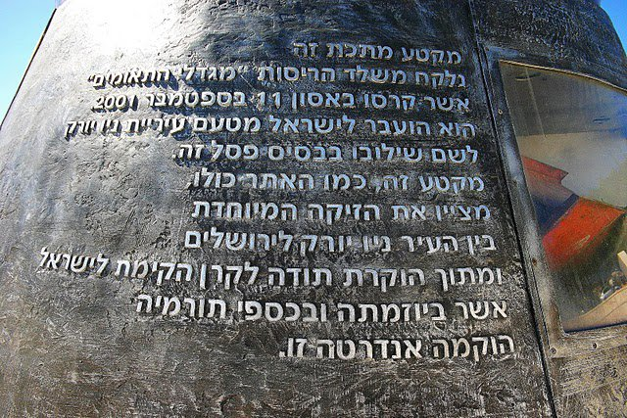
Surrounding the monument are plaques with the names of the victims of 9/11.
It is the only memorial outside the U.S. that includes the names of all who
perished in the terrorist attacks.
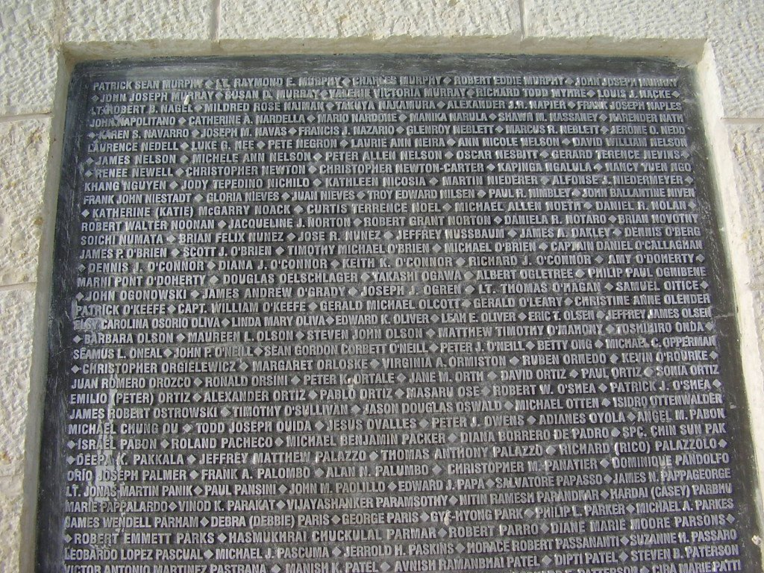

Including 5 Israeli citizens The site solemnly overlooks Jerusalem’s largest cemetery, Har HaMenuchot. The monument is often used for memorial and commemoration services.
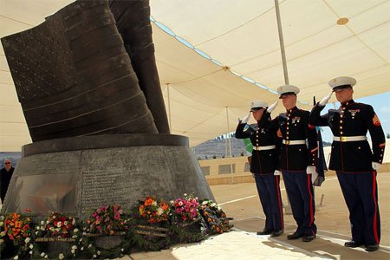
A powerful memorial from a powerful ally.

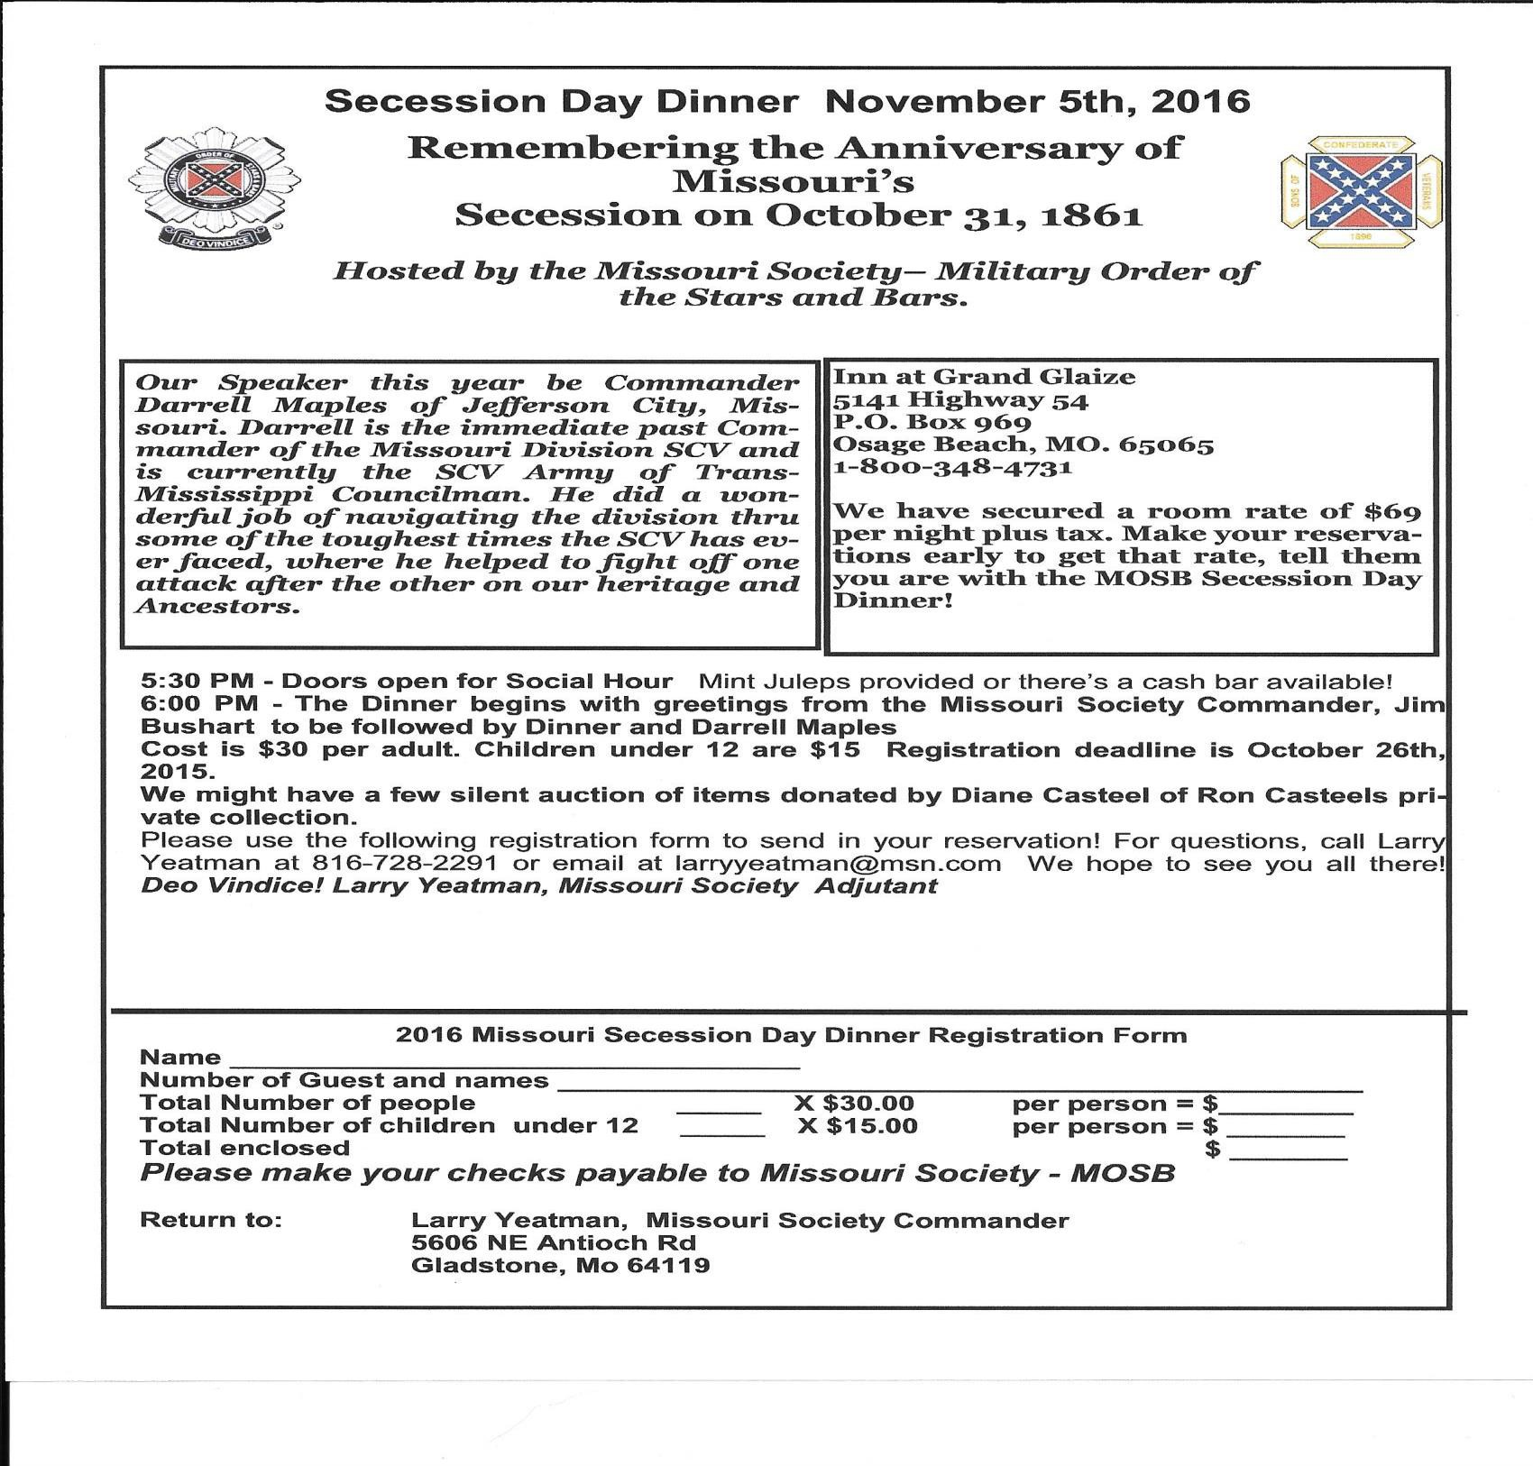

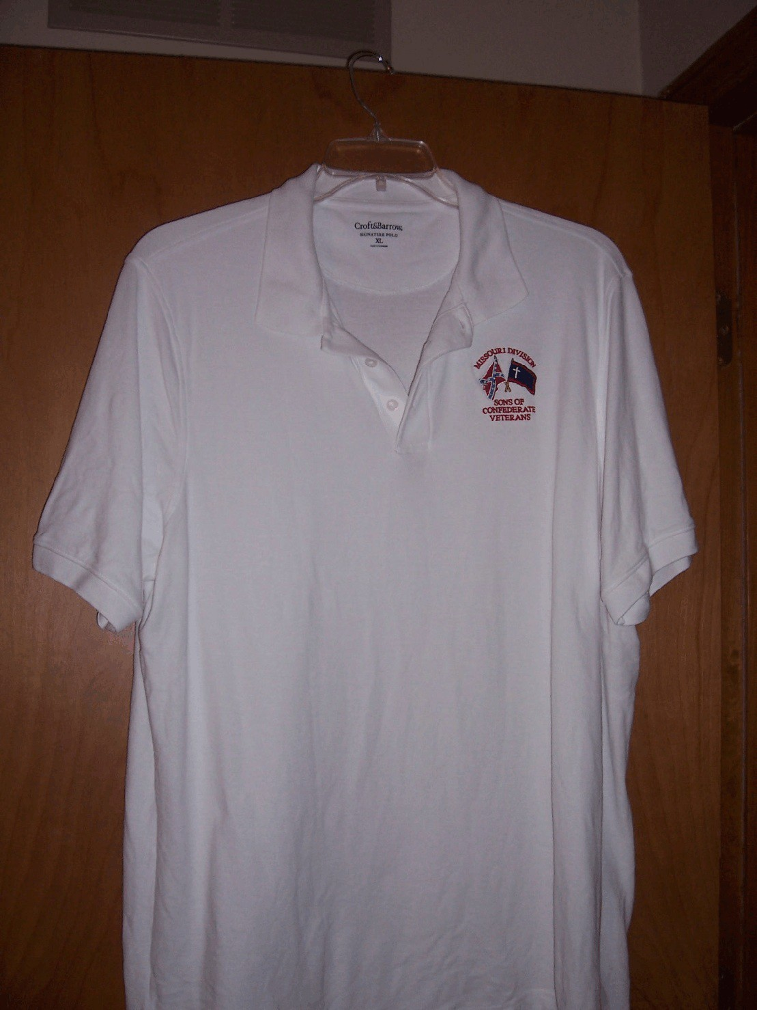

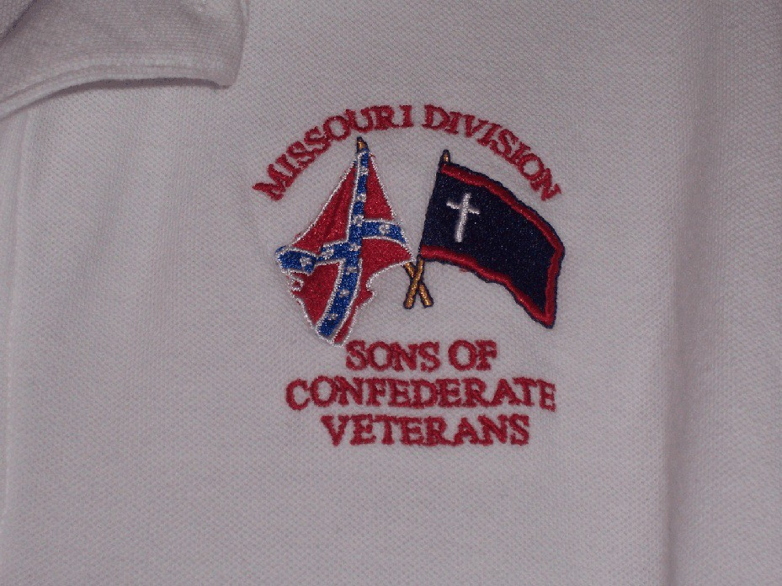

M

Missouri Division Confederate Flag Polo Shirt Order Form

Name or Camp Name/Number: ________________________________________________

Contact Person: ________________________________________________

Phone Number: ________________________________________________

Email: ________________________________________________

Shirts are available in White/Gray/Tan

Number of Shirts:__________ Size:__________ Color:__________ Total Cost:$_________

Number of Shirts:__________ Size:__________ Color:__________ Total Cost:$_________

Number of Shirts:__________ Size:__________ Color:__________ Total Cost:$_________

Number of Shirts:__________ Size:__________ Color:__________ Total Cost:$_________

Number of Shirts:__________ Size:__________ Color:__________ Total Cost:$_________

Number of Shirts:__________ Size:__________ Color:__________ Total Cost:$_________

All orders can be sent to:

Darrell Maples, 2416 Iven Rd., Jefferson City, MO 65101. Best to do
as a "Camp order" with all ordered at one time, and a mailing address to
send the shirts to. Checks made to MO Division - SCV.

* Use Back of Form if necessary

2016 PROGRAM
STERLING PRICE CAMP #145
SONS OF CONFEDERATE VETERANS

Tuesday, January 12, 2016 “Missouri State Guard, Patriot Army of Missouri”
John Harris, Sterling Price Camp SCV

Tuesday, February 9, 2016 “The Flight of Jefferson Davis”
Gale Red, Dixon Camp SCV

Tuesday, March 8, 2016 “Churchill's Corps at the Battle of Pleasant Hill”
Michael Banasik, Historian, Author and Retired US Army Officer

Tuesday, April 12, 2016 “The Rope and the Open Square:
Civil War Crime and Punishment”
Tom Pearson, Library Subject Specialist, Saint Louis Public Library

Tuesday, May 10, 2016 “Camp Jackson”
Gene Dressel, Utz Camp SCV

Tuesday, June 14, 2016 “The Sultana Tragedy”
William Napier, Sterling Price Camp SCV

Tuesday, September 13, 2016 “The Much Maligned Mountain Howitzer”
Charles Brulle, 1st Sergeant, 13th MO Light Artillery, CSA

Tuesday, October 11, 2016 “The Battle of Lexington”
Major (Retired) Douglas L Gifford, US Army, battlefield tour guide and author

Tuesday, November 8, 2016 “The Gettysburg Campaign”
Zachary Burnett, Sterling Price Camp SCV

Tuesday, December 13, 2016 “The Life and Times of Louis Rosché (1852-
1937); Pioneer Steamboatman of St. Louis”
Barney Bradshaw, Missouri History Museum

